ADF CI/CD Pipelines

1. Infrastructure
2. Preparing for ADF Integration
3. Creating a pipeline from a template
4. Deploy with Release Pipeline

# CI/CD Workflow:

1. Work on new feature branch
2. Test

Integrate in collaboration branch.

1. Push to qa Environment
2. Test stg Environment
3. Push to production Environment.

# Infrastructure

Thoughtfully consider a naming strategy:

Example **{bg}-{projName}-{component}-{environment}**

-Create for each environment (dev, qa, prod)

1. Azure Resource Group

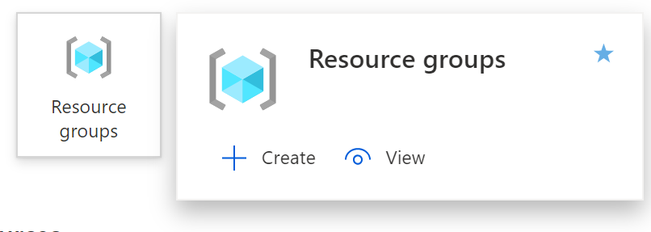

Following the suggestion, the resource group is given the name

**mm-proj1-rg-dev**

**mm-proj1-rg-qa**

**mm-proj1-rg-prod**

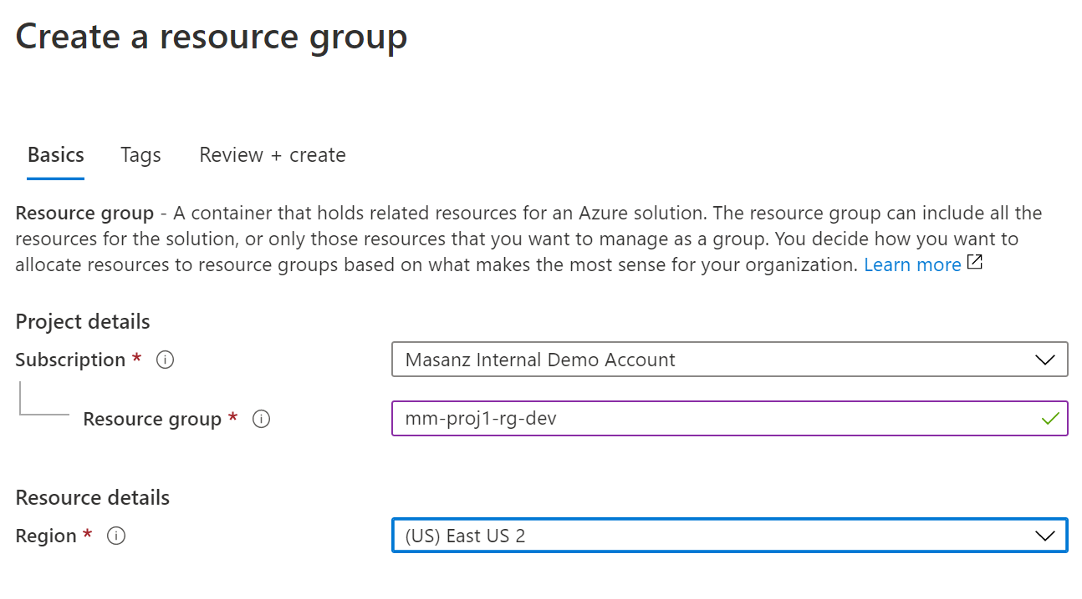

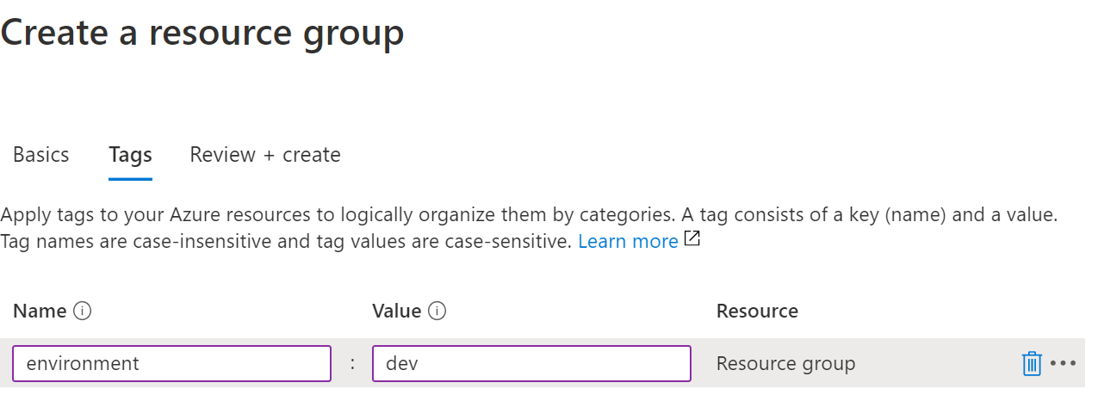

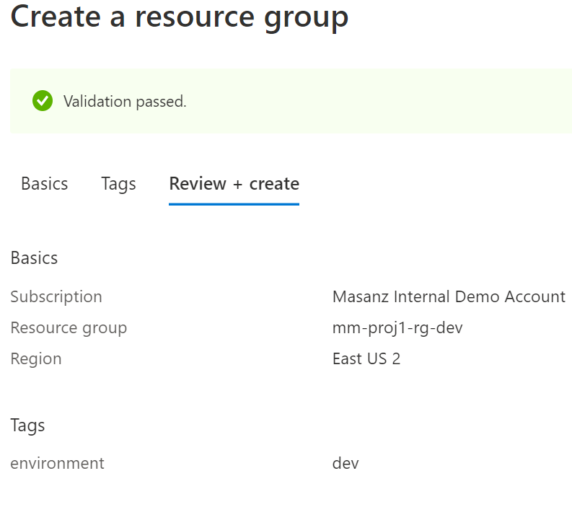

Finally Click on the Create Button

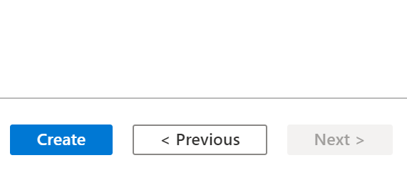

2. Azure Data Factory

Create a new resource searching for ‘Data Factory’. Technically, the pipeline would be able to create the qa and prod environments for us, but we do need to link the qa and prod environments to our key vault, so we will go ahead and create them manually to make sure we can provide them with the correct permissions.

mm-proj1-adf-dev

mm-proj1-adf-qa

mm-proj1-adf-prod

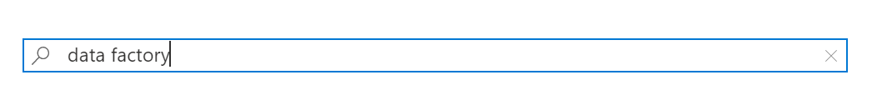

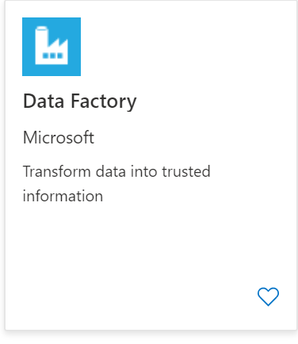

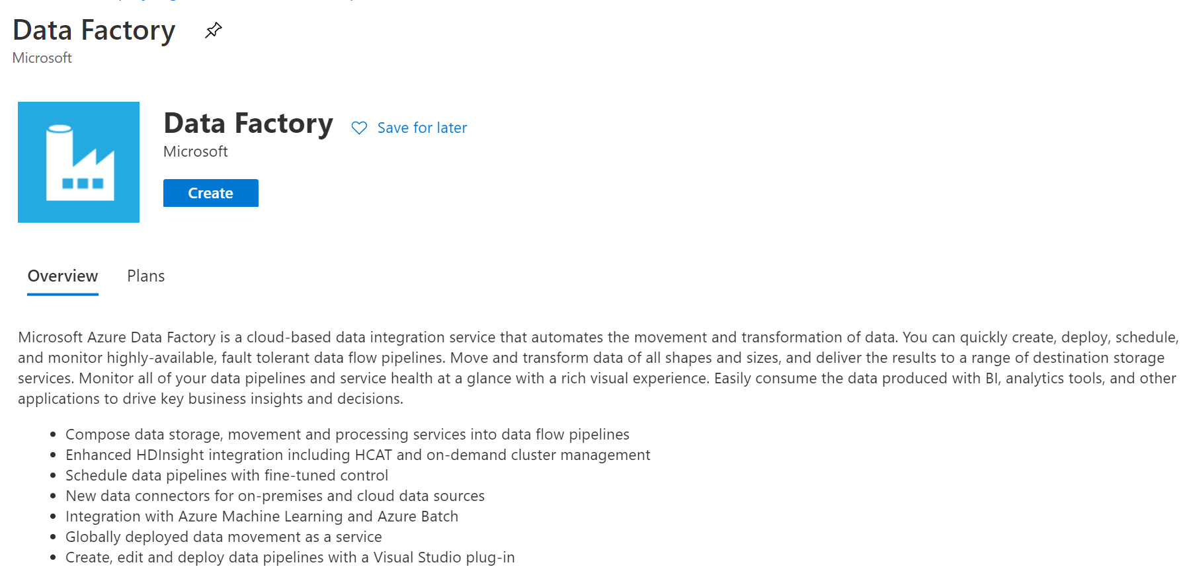

Provide with name following convention

mm-proj1-adf-dev, carefully select the correct region

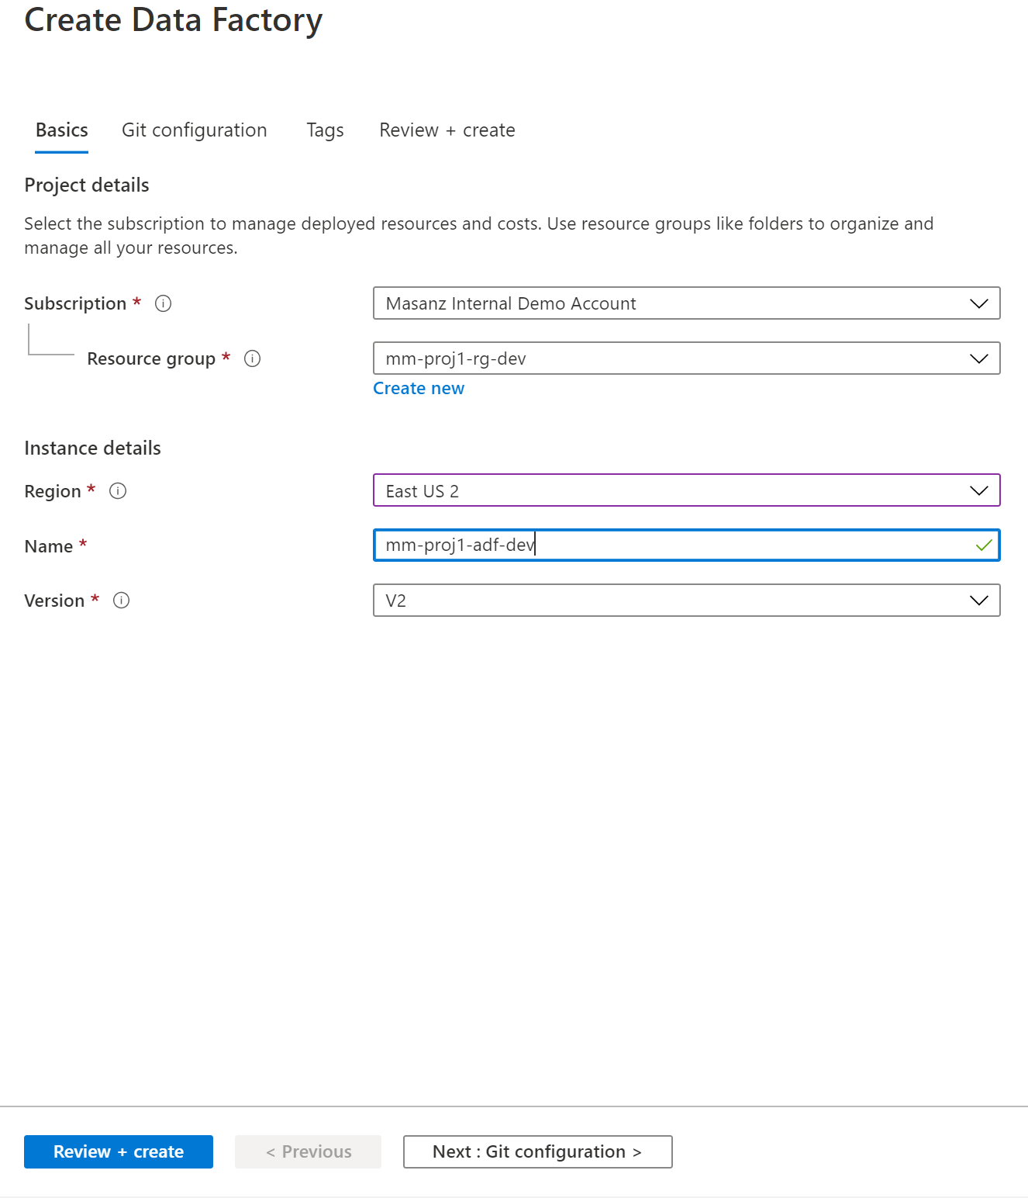

Move onto the ‘Git configuraiton’

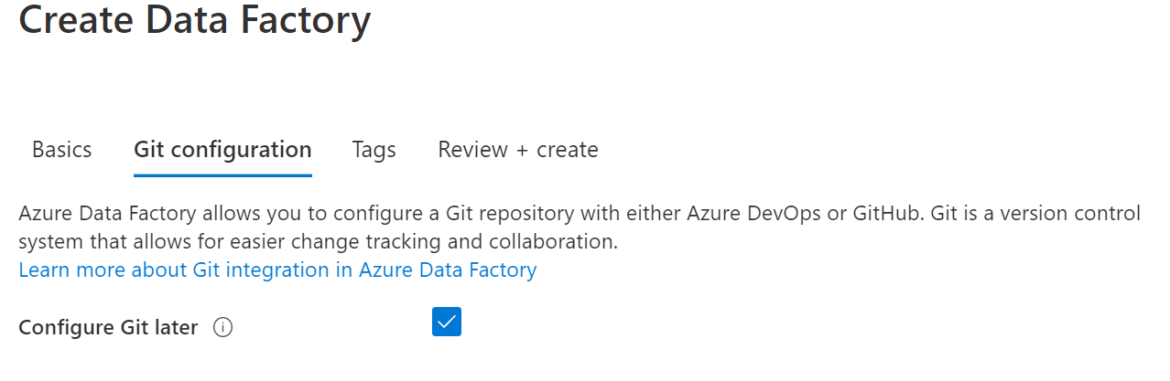

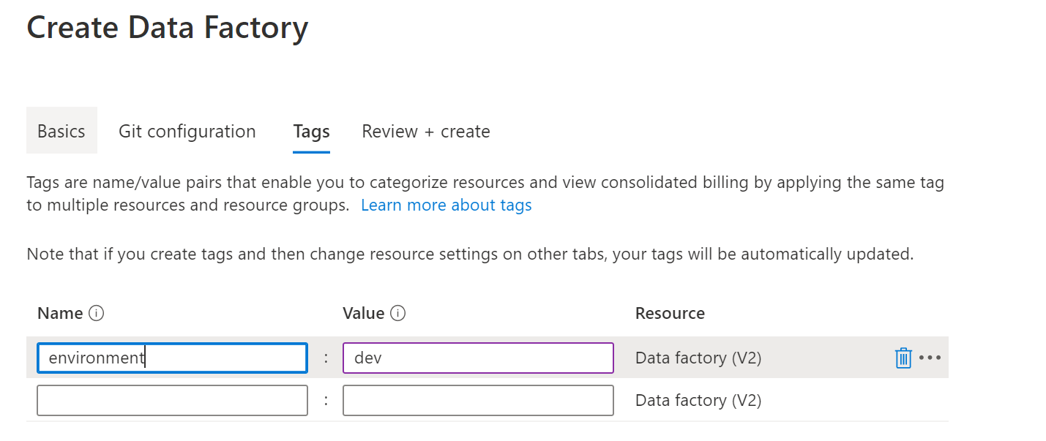

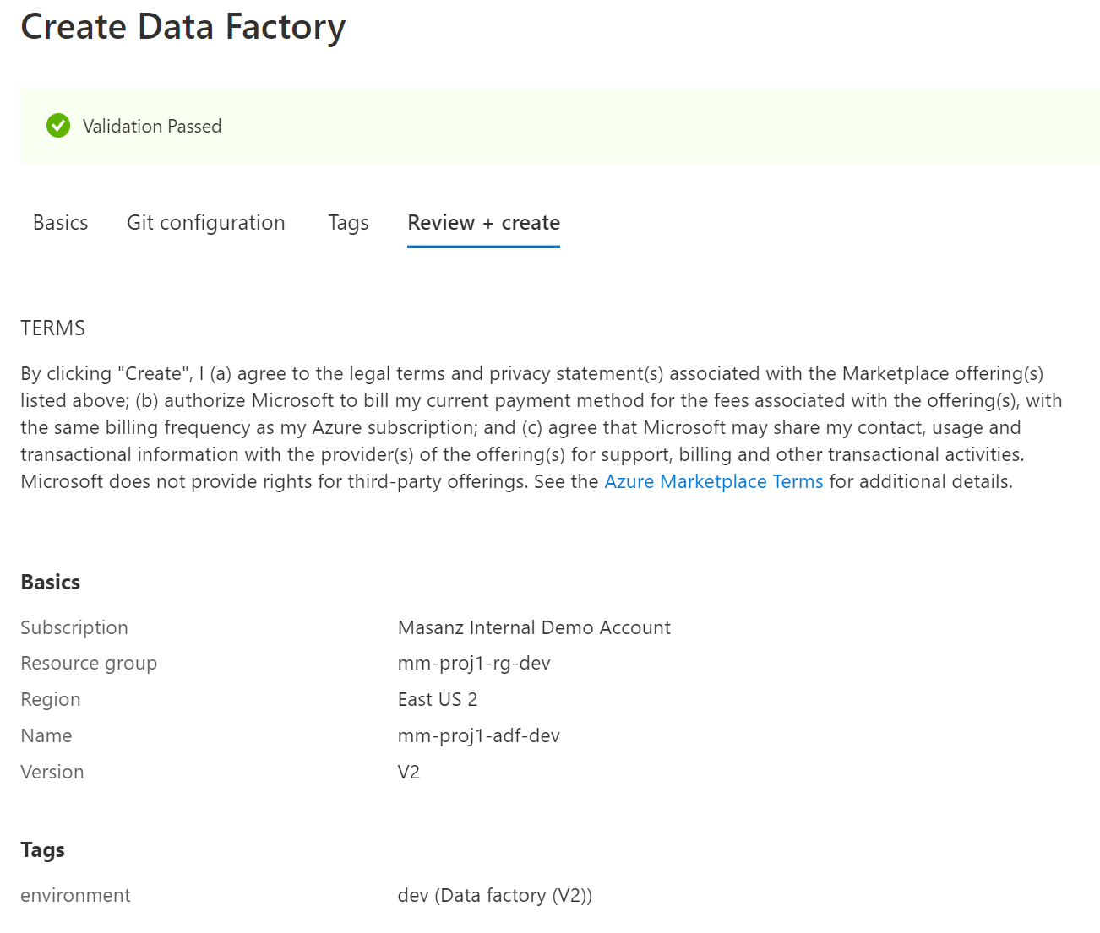



1. Azure Key Vault

**mm-proj1-kv-dev**

**mm-proj1-kv-qa**

**mm-proj1-kv-prod**

Search for Key Vault

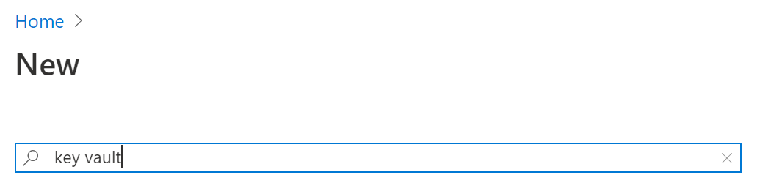

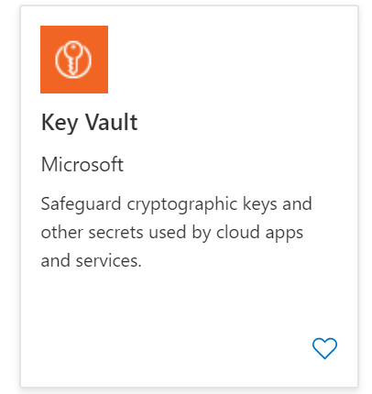

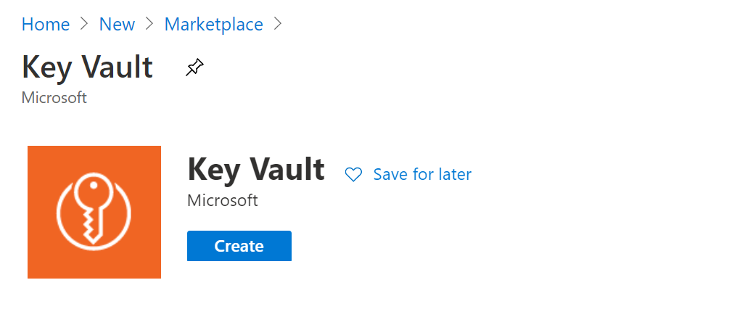

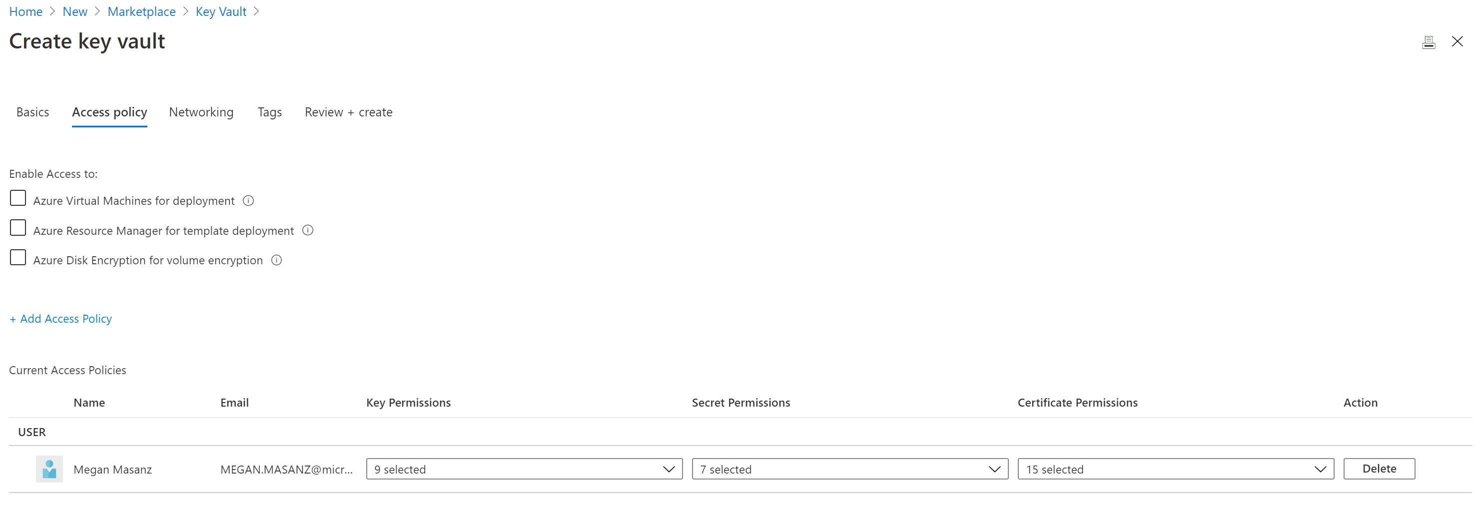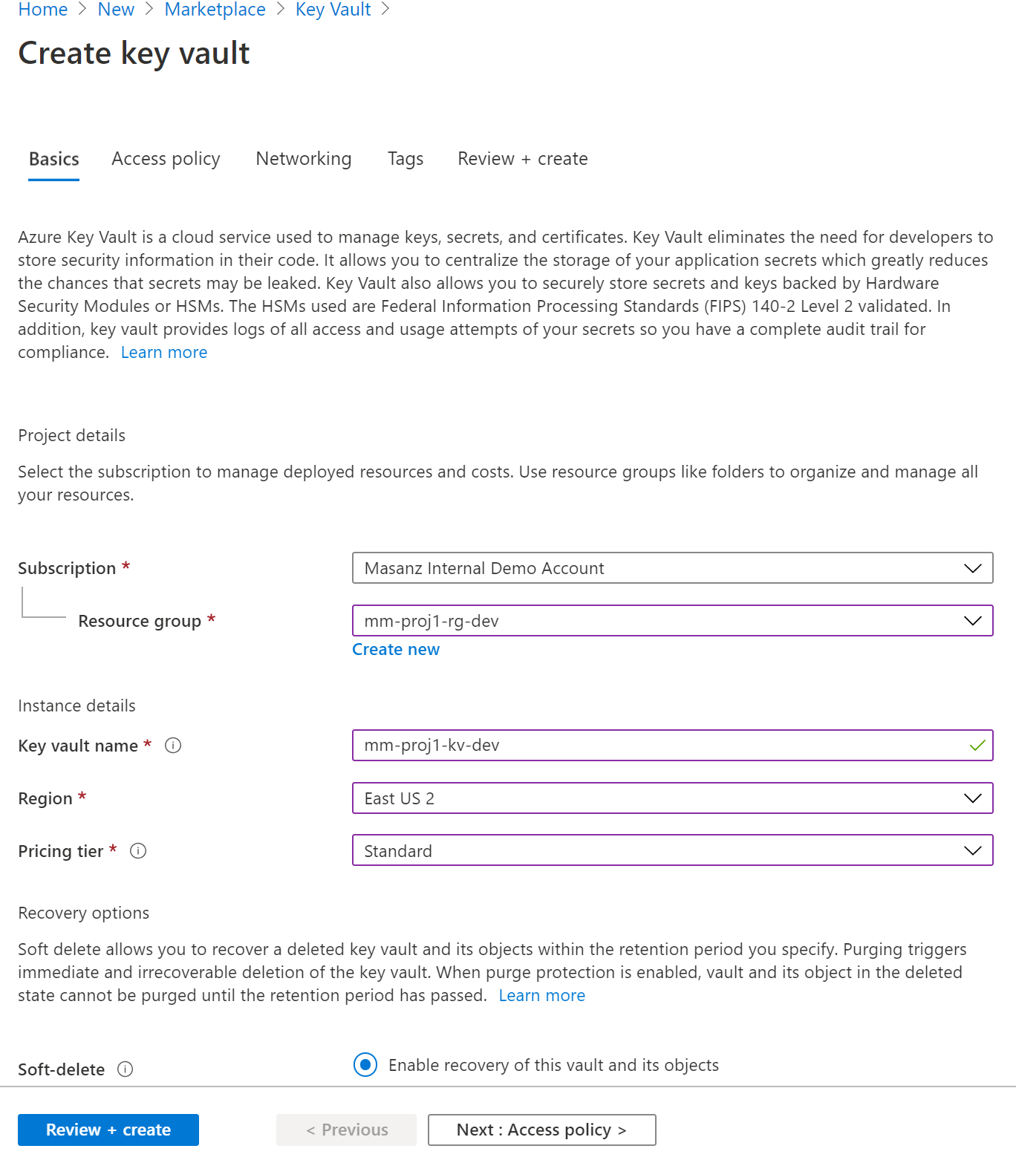

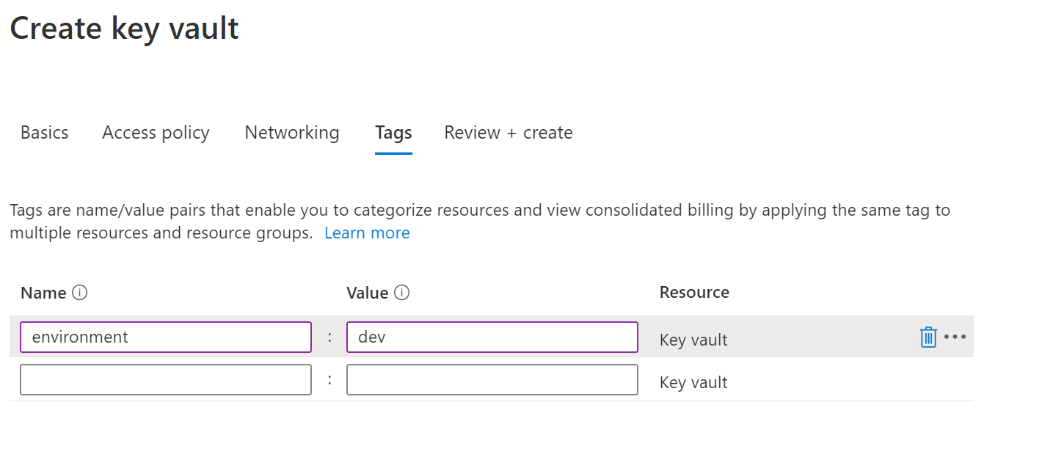

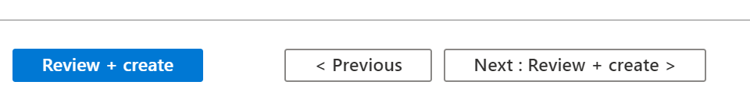

1. Create Azure Storage Account

mmxproj1xstordev

mmxproj1xstorqa

mmxproj1xstorprod

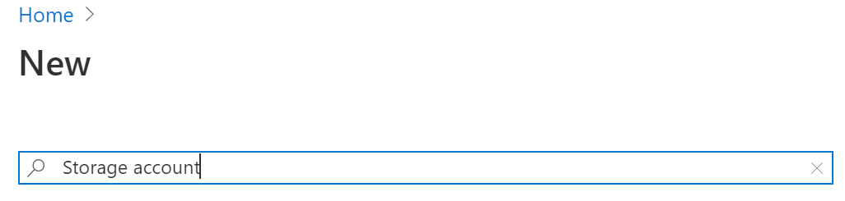

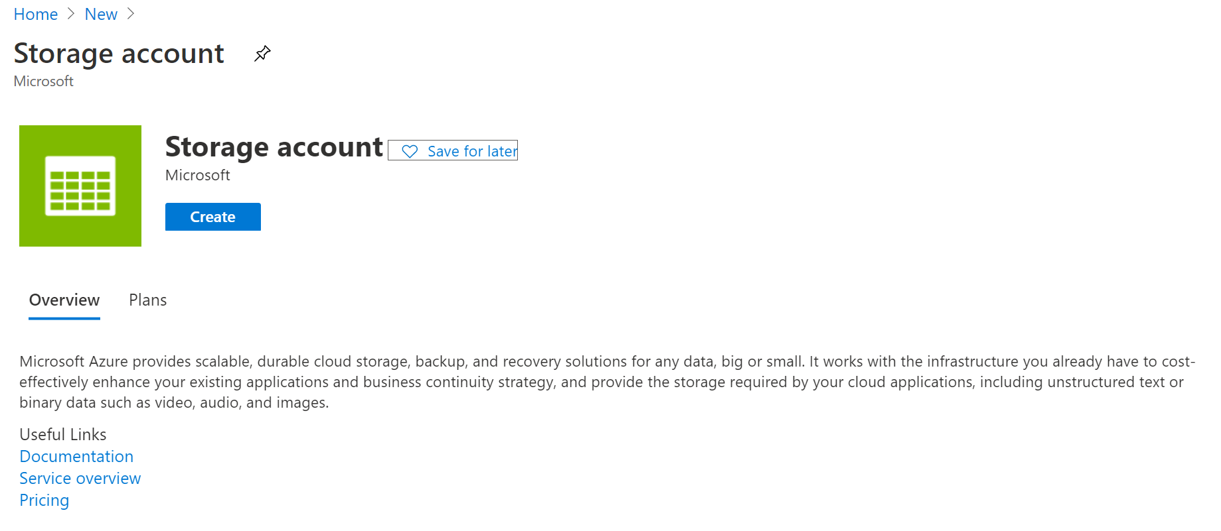

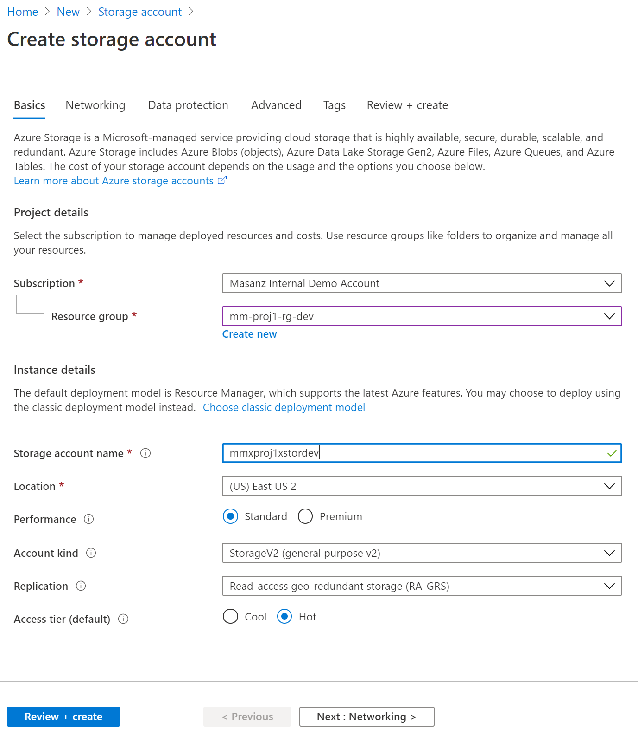

1. Create Containers inside Storage Account ‘datasource’ & ‘datadest’

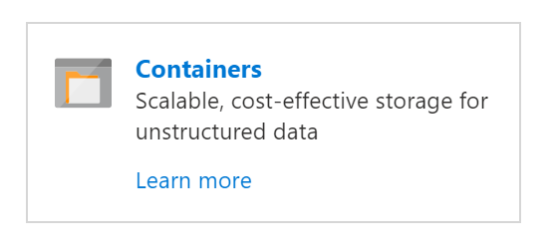  
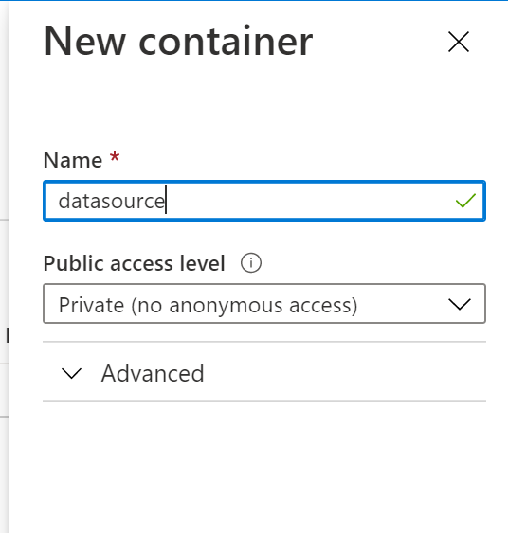

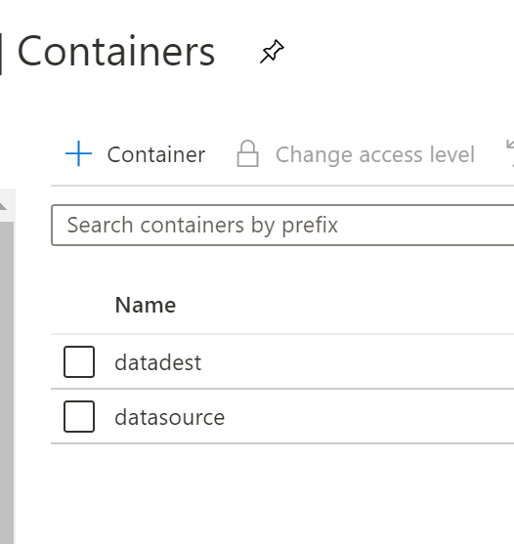

# Preparing for ADF Integration

-Key Vault Connection String

-ADF Key Vault Access

1. Key vault will store your sensitive information, like connection strings. Go to storage account and copy the Access key we will store it in a variable called ‘blob-connection’

In each key vault create a blob storage connection string. Go to the dev instance of your storage account and grab the key from ‘Access keys’

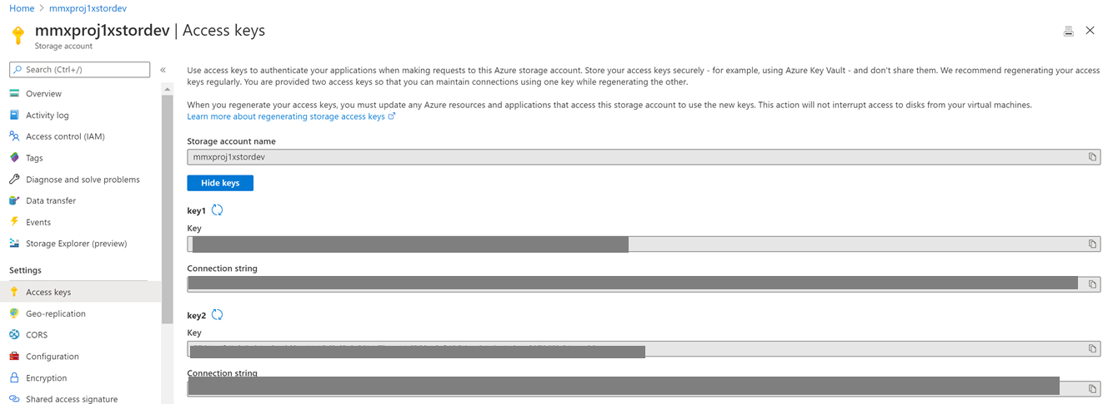

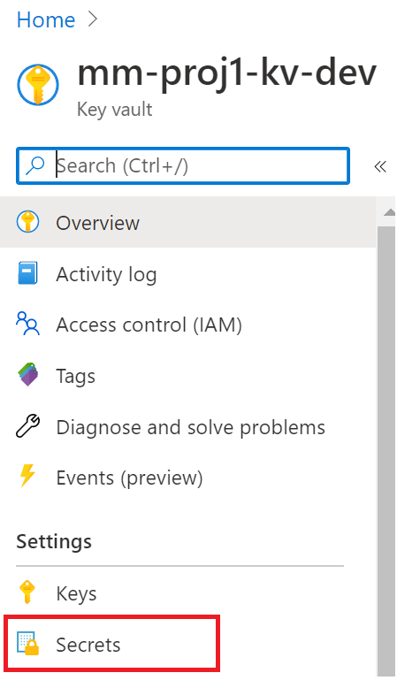

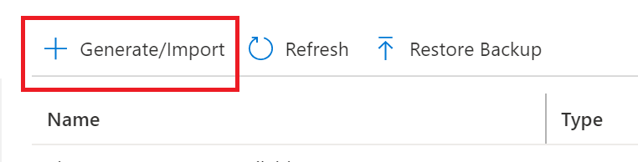

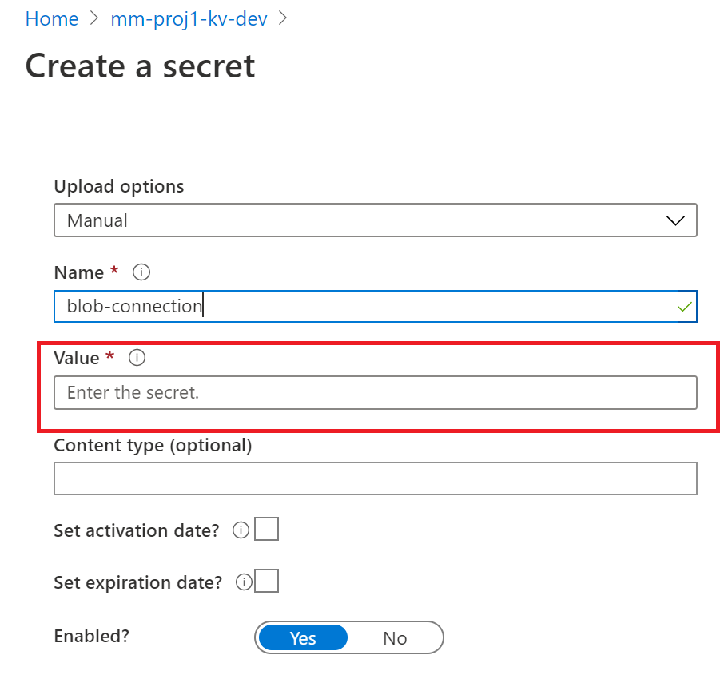

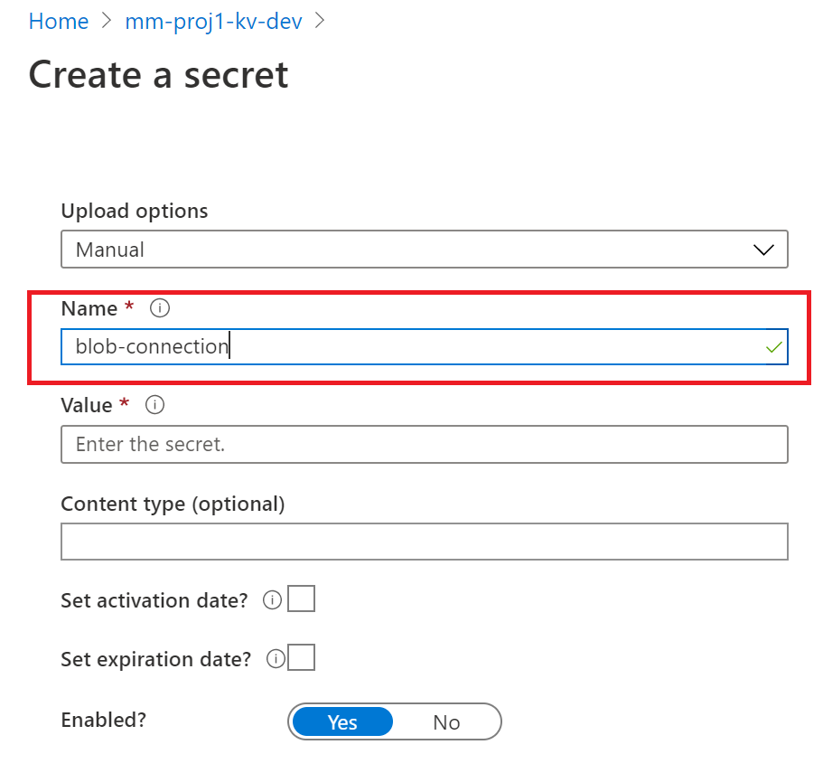

Also create an environment per key vault call: environment. Give the following values:

environment dev

environment qa

environment prod

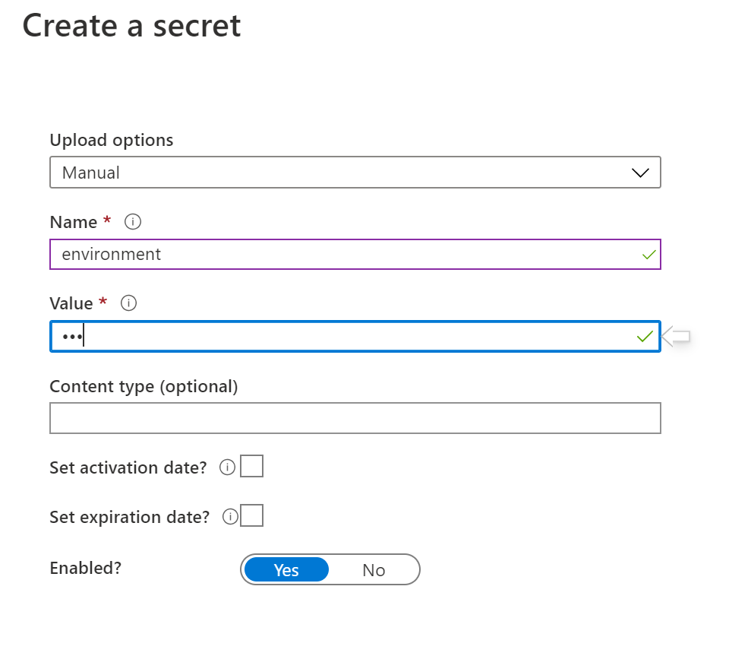

2. MSI Key Vault Access

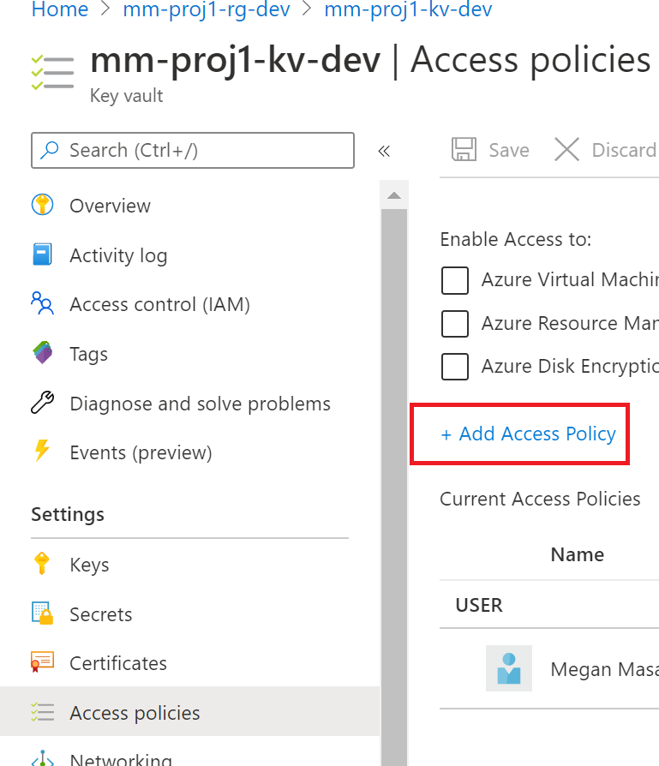

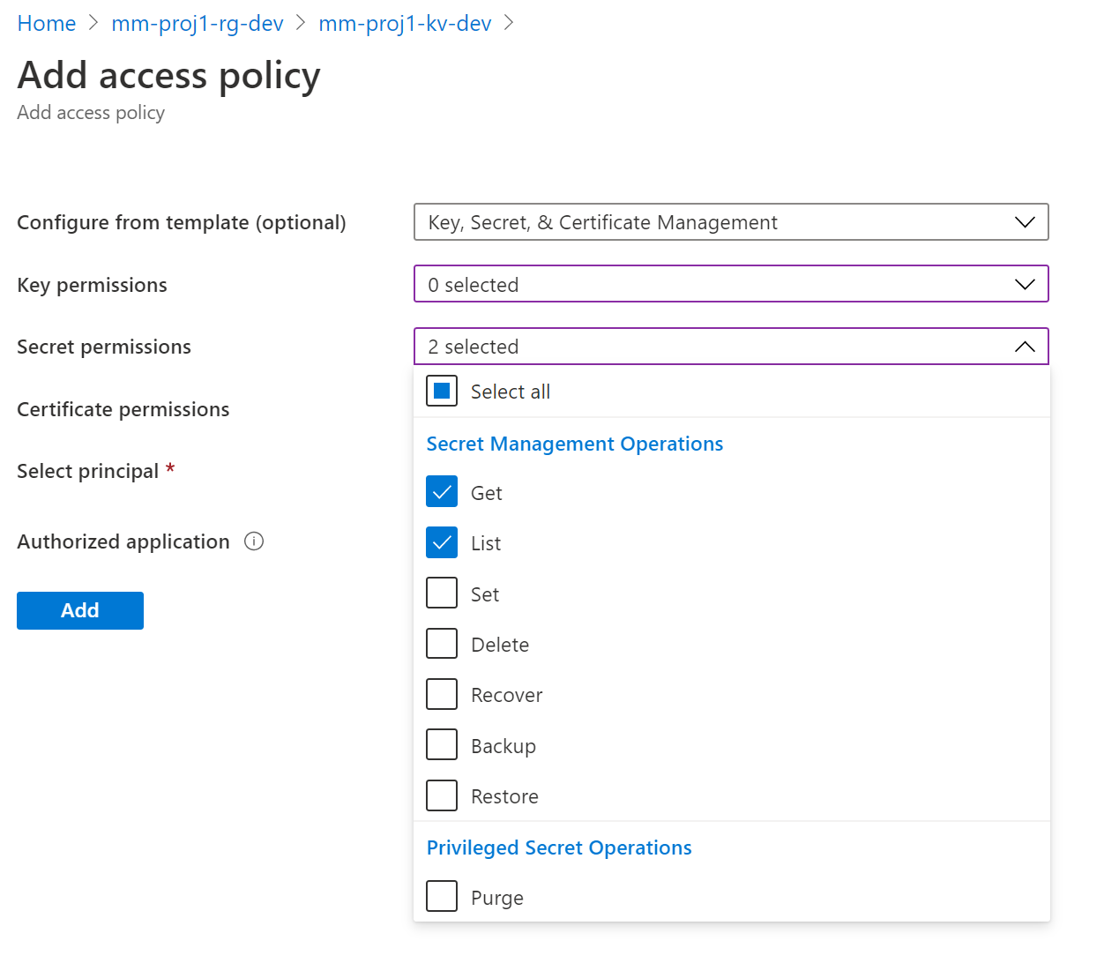

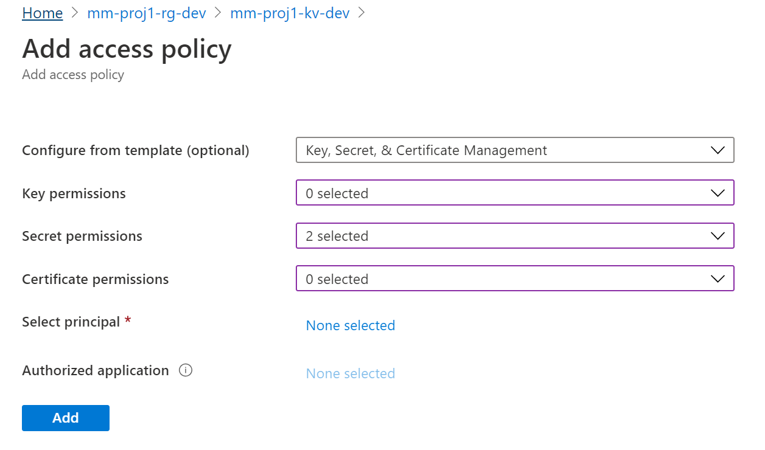

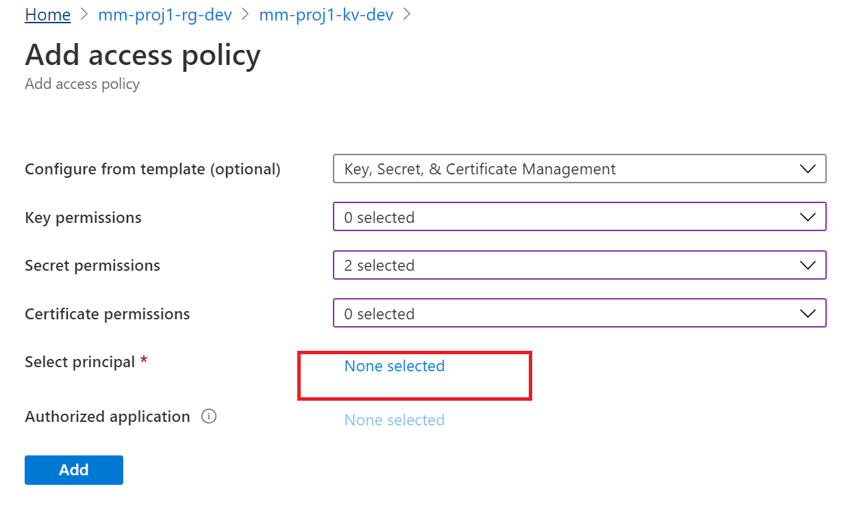

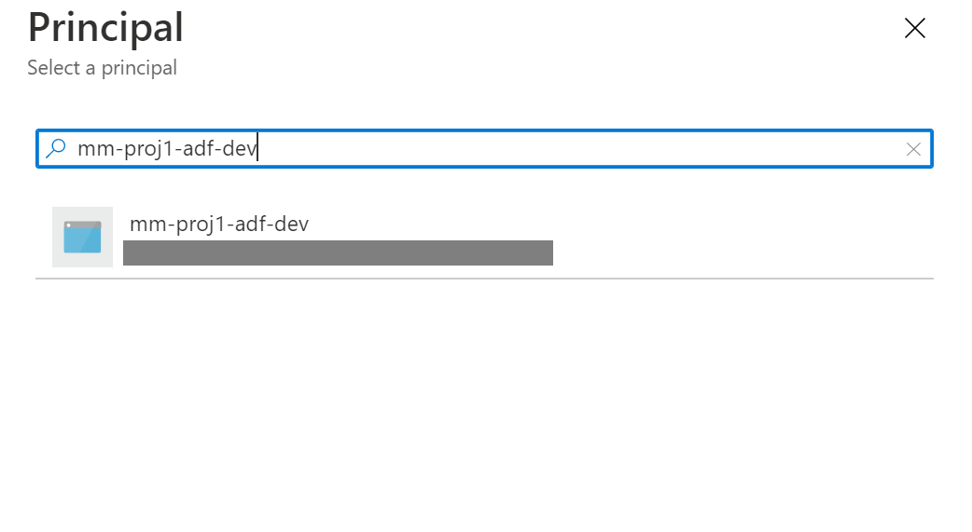

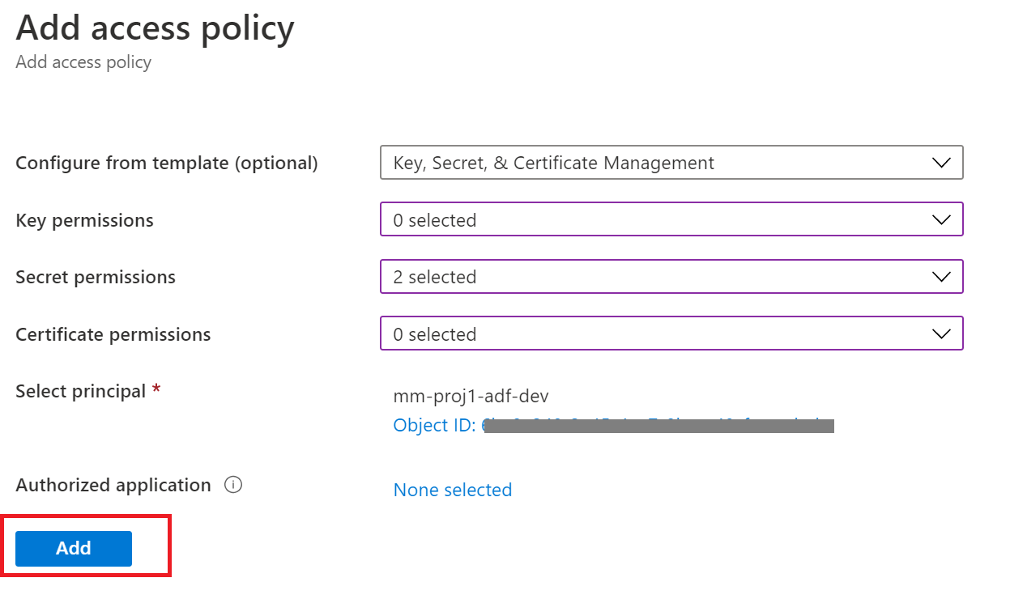

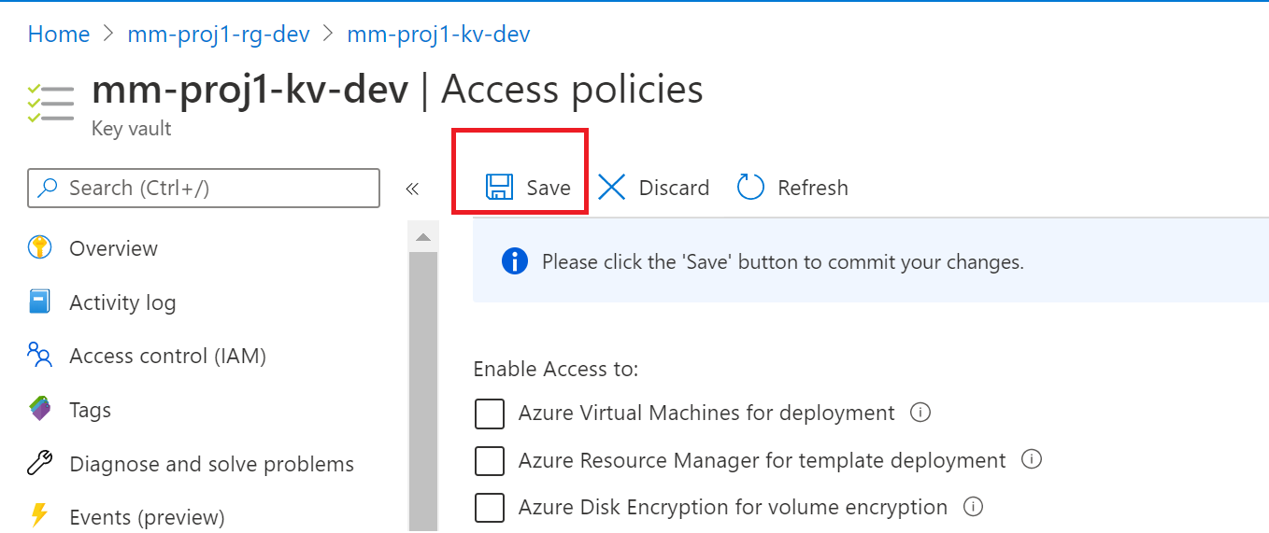

Once this has been completed, we will do the same for the QA and Prod Environment instances of ADF.

# 3. Pipeline Creation

In the dev instance click on the ‘Author & Monitor’ button

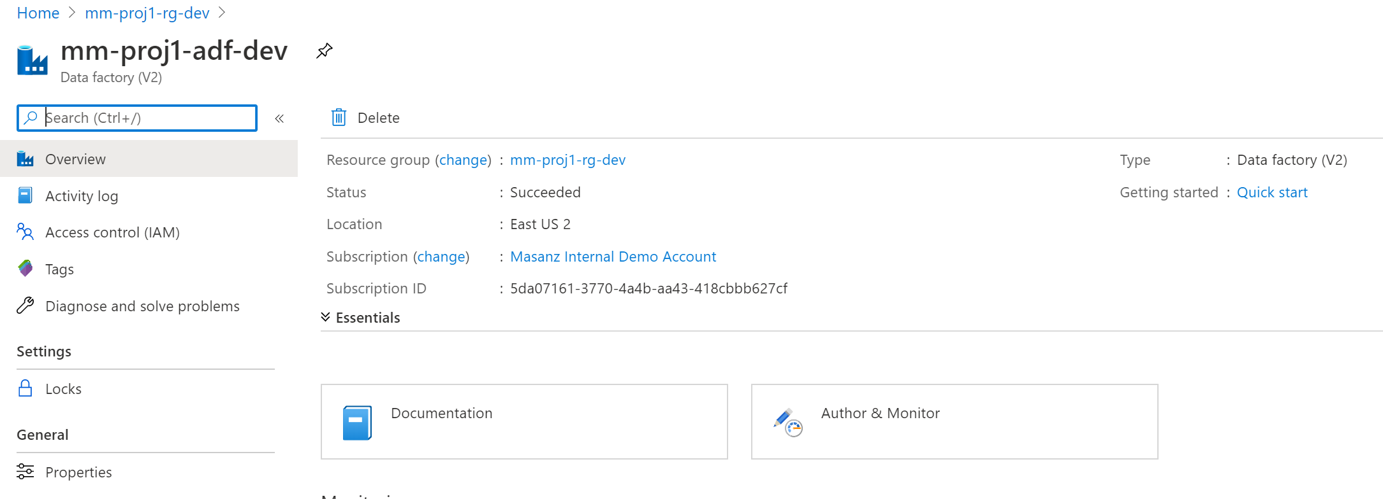

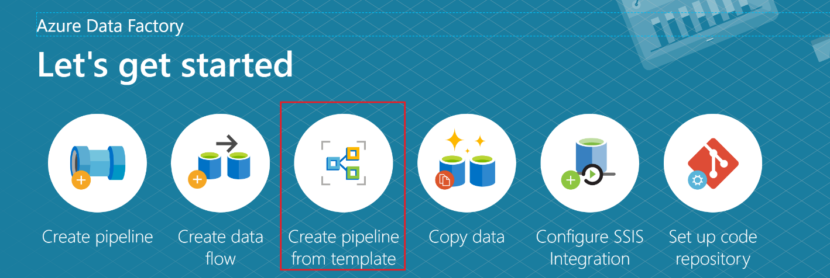

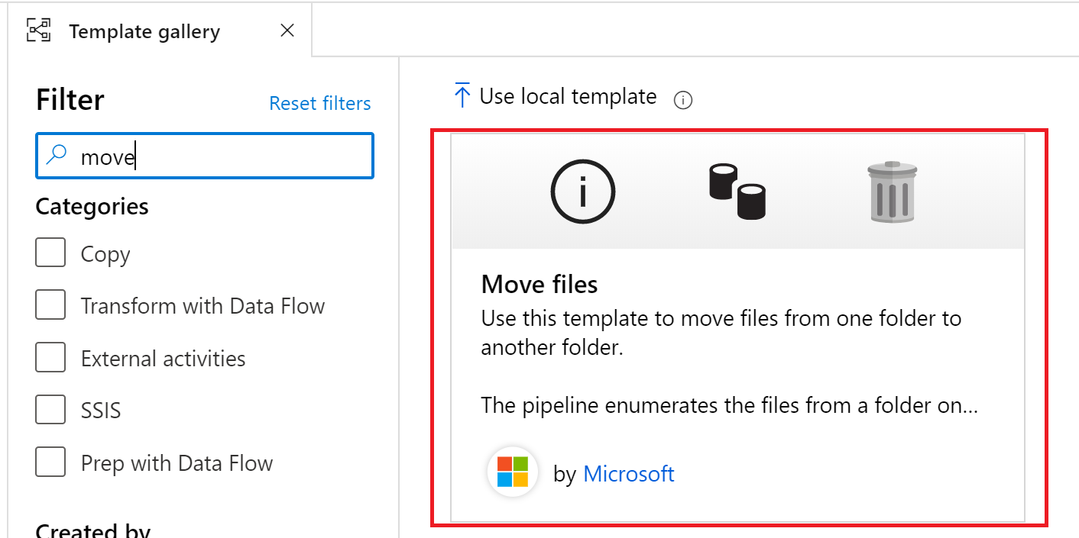

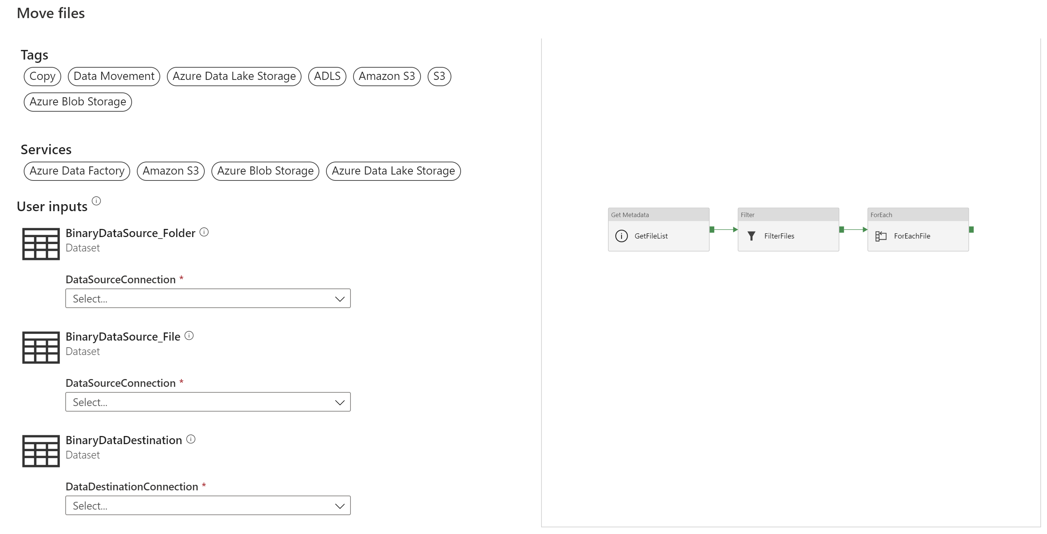

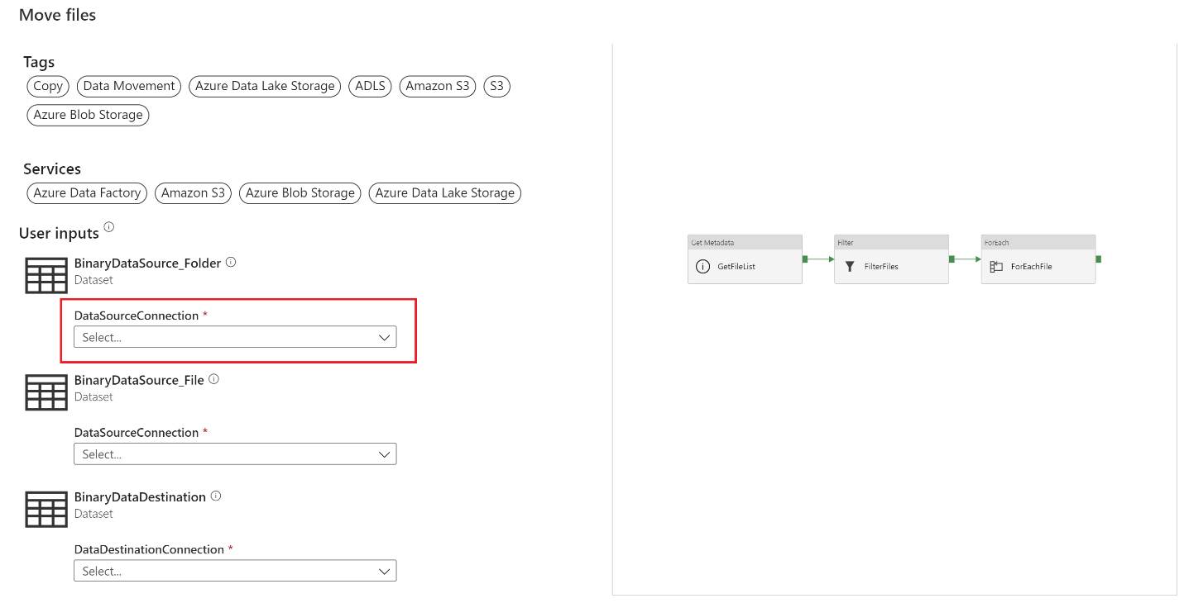

Selecting a new DataSourceConnection we are able to create a new linked service.

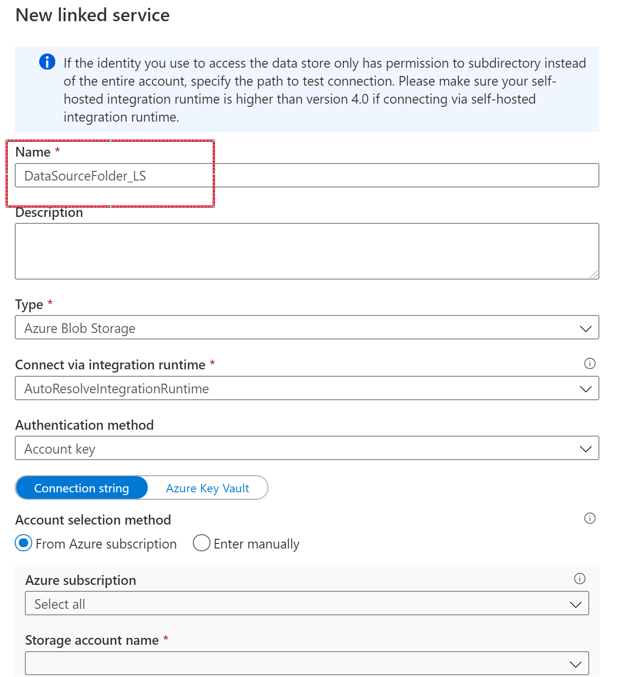

Swap over to Azure Key Vault and we will create a linked service for Azure Key Vault as well.

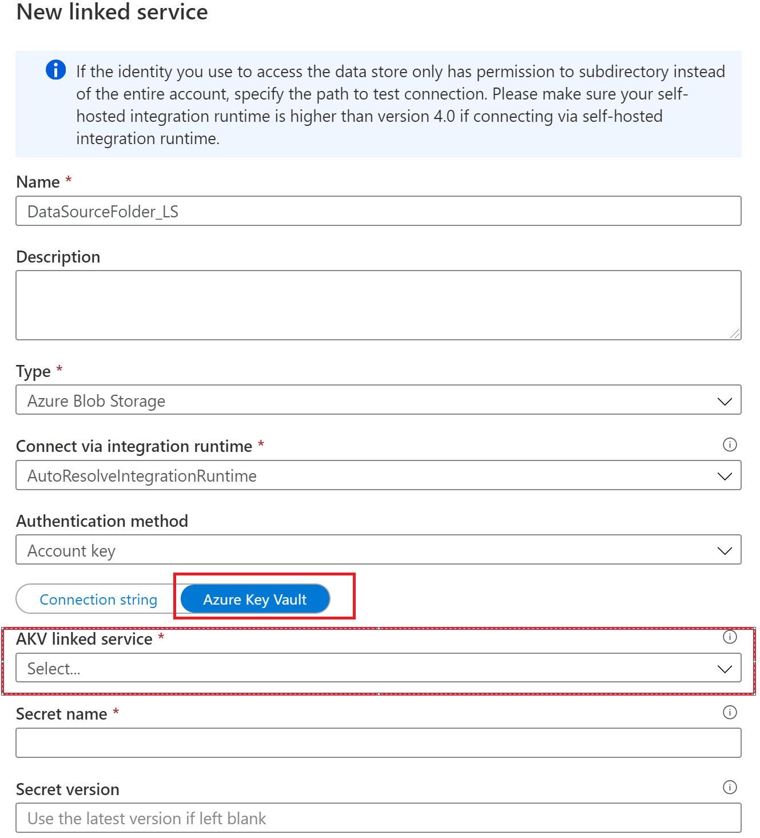

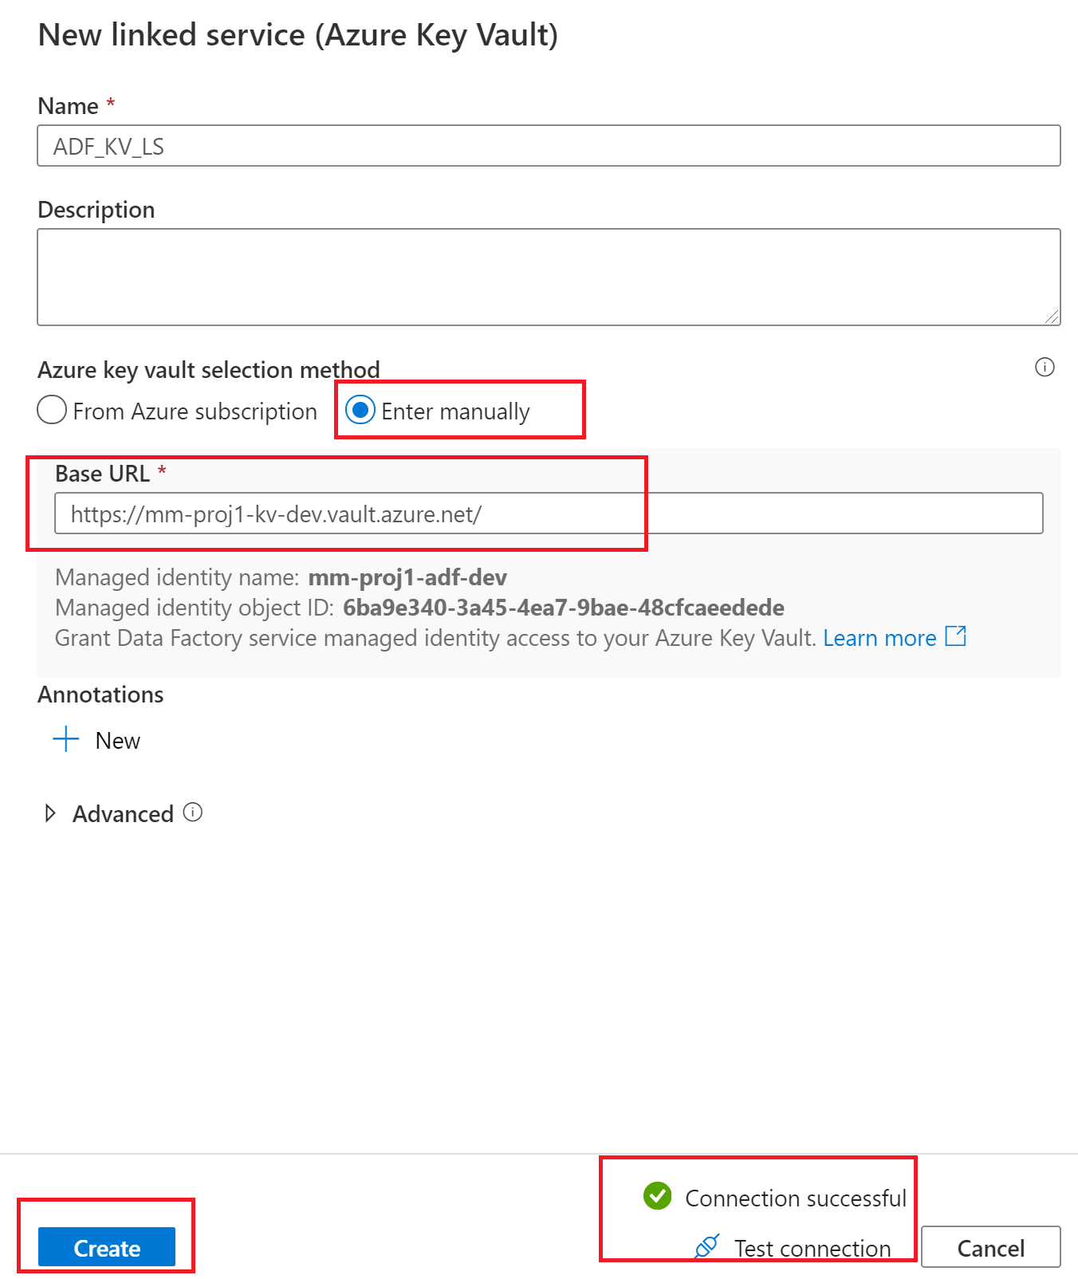

After selecting the create button

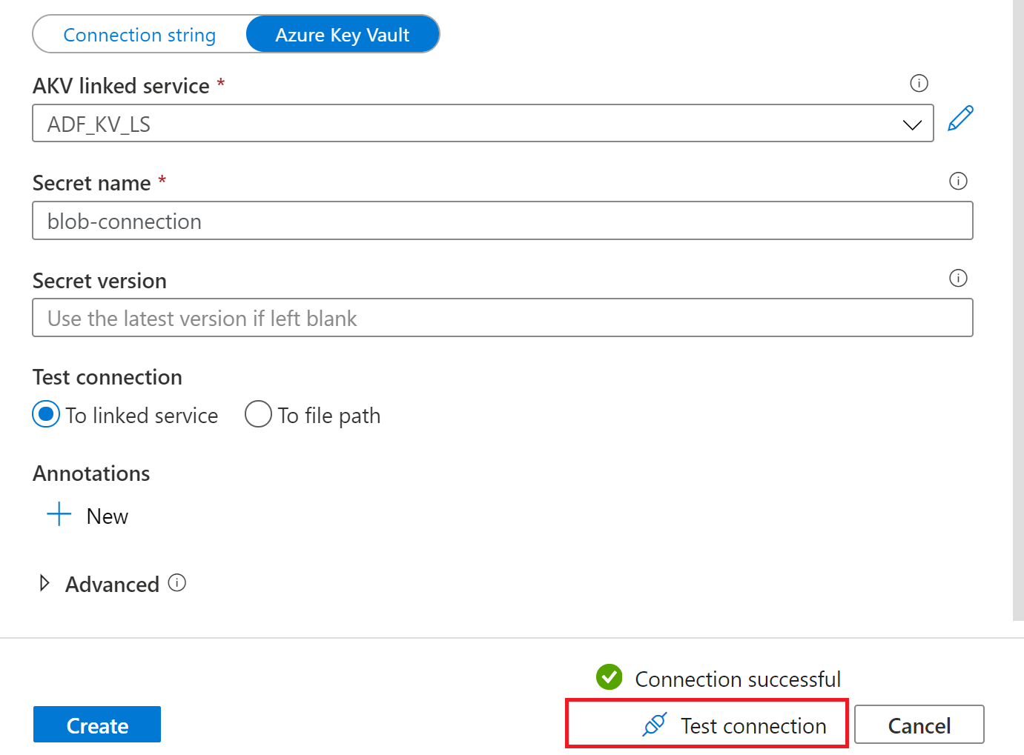

Let all 3 use the same Linked service

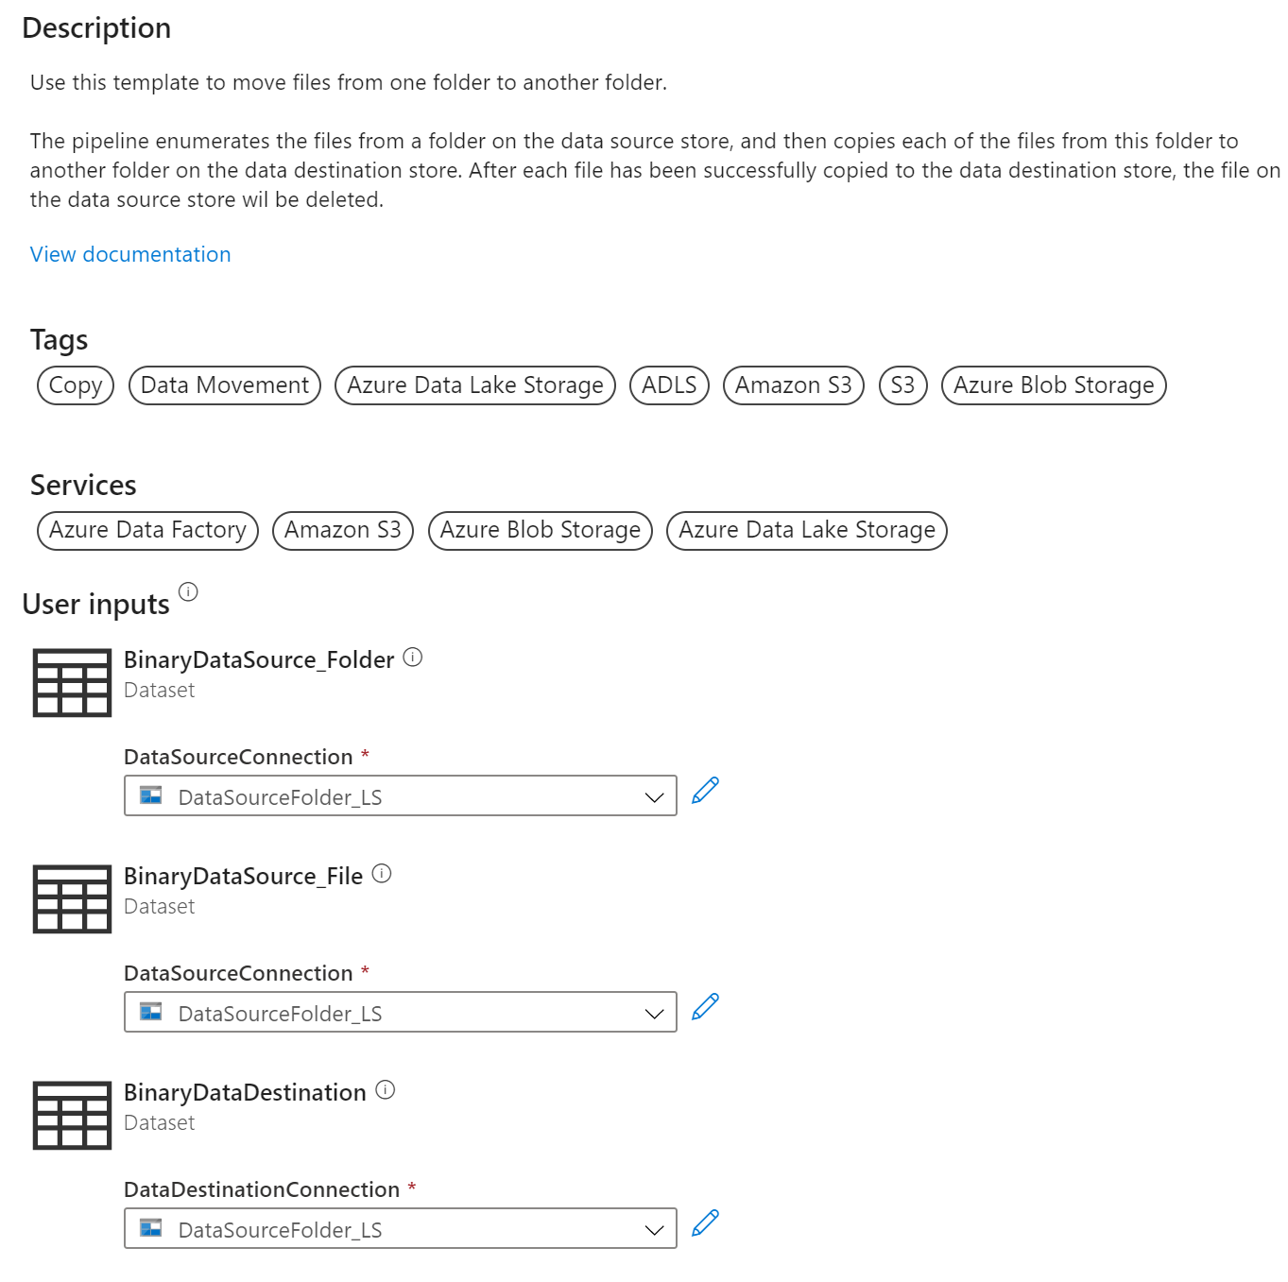

Then select ‘use this template’

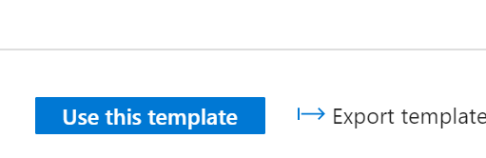

Recall that we created storage containers in each of our environments, lets add them to the parameters inside the ADF pipeline we just created from the template

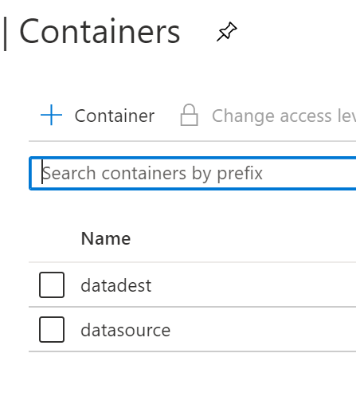

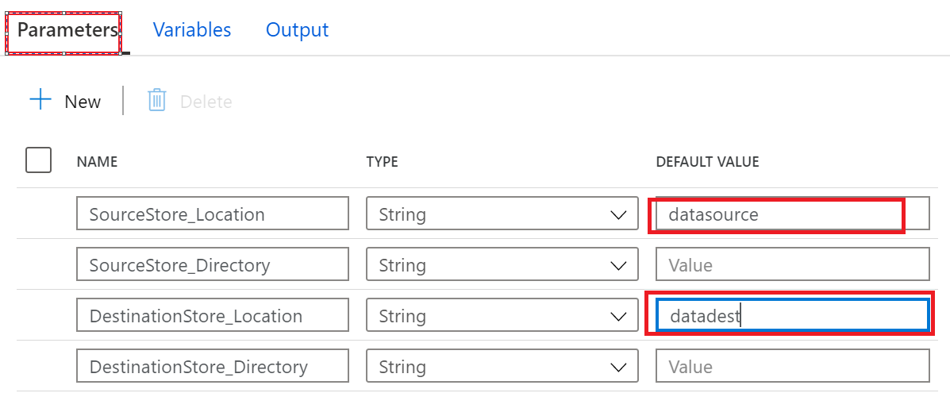

Let’s validate and publish

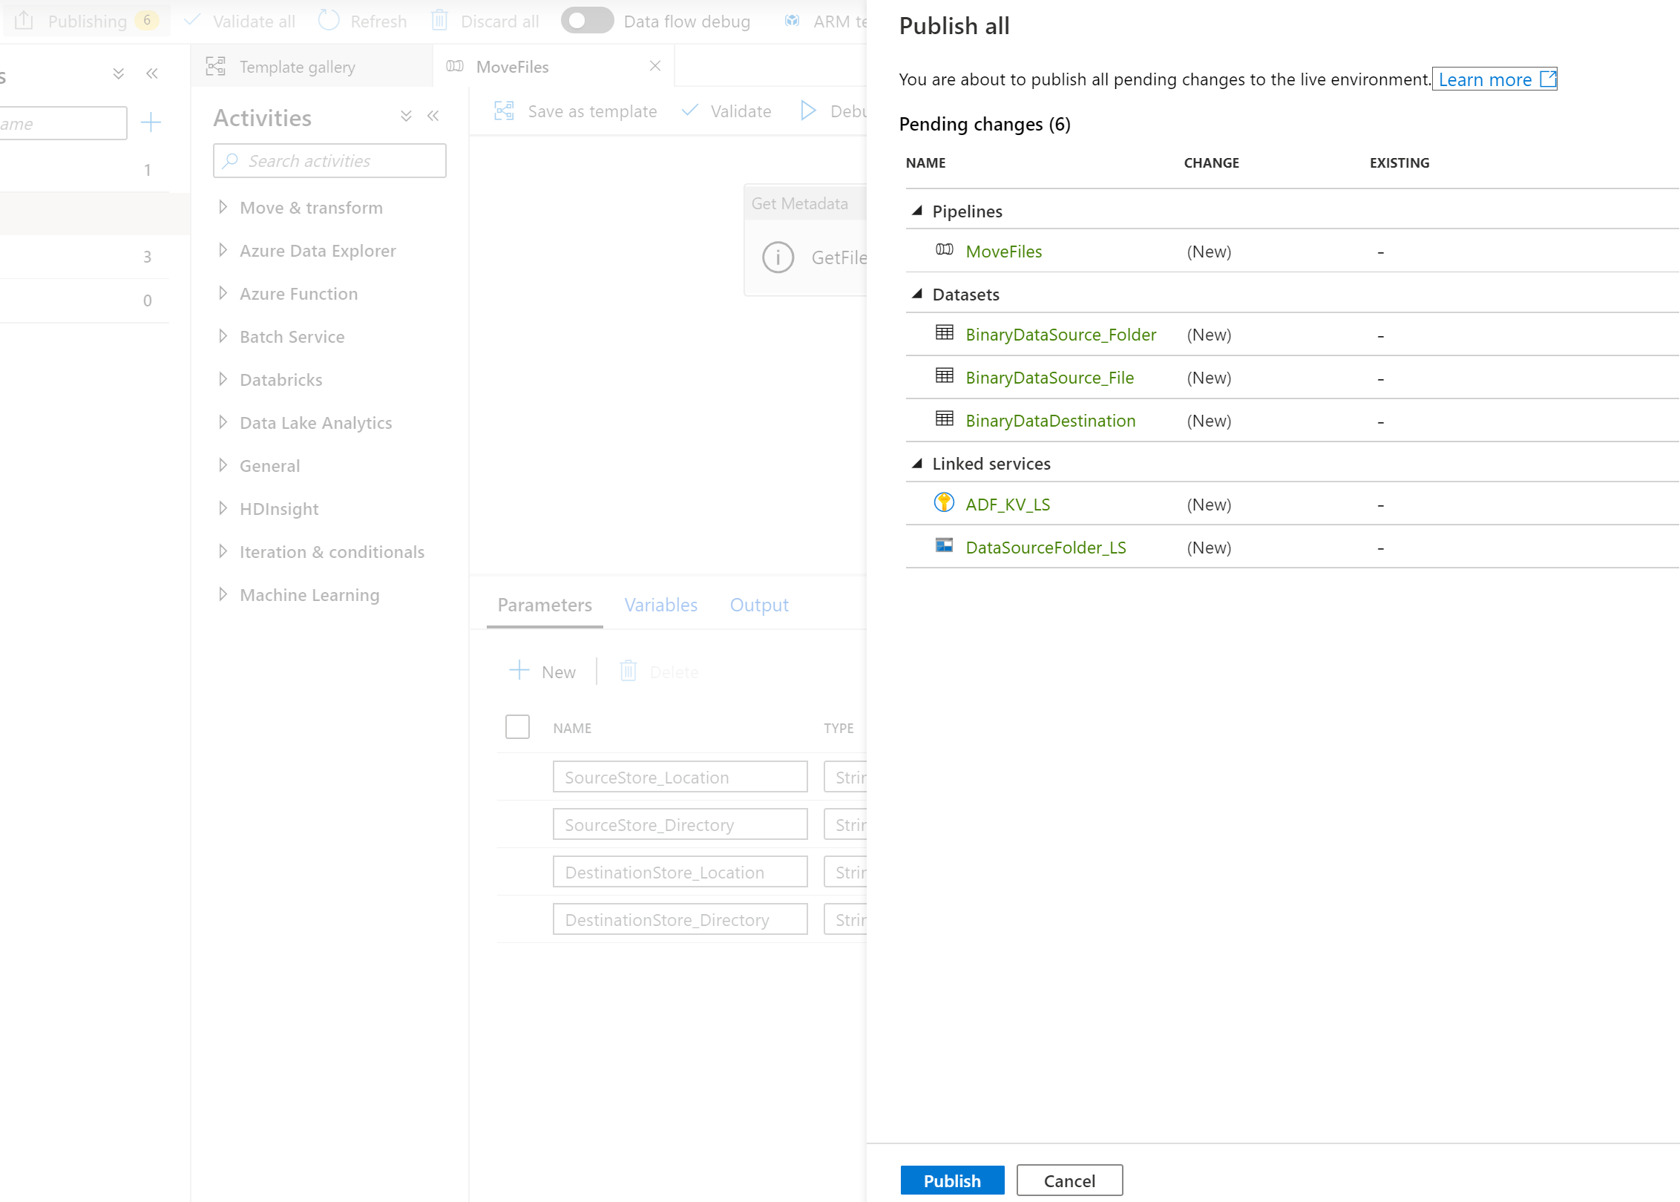

If we want, we can go to Storage Explorer and view the storage accounts.

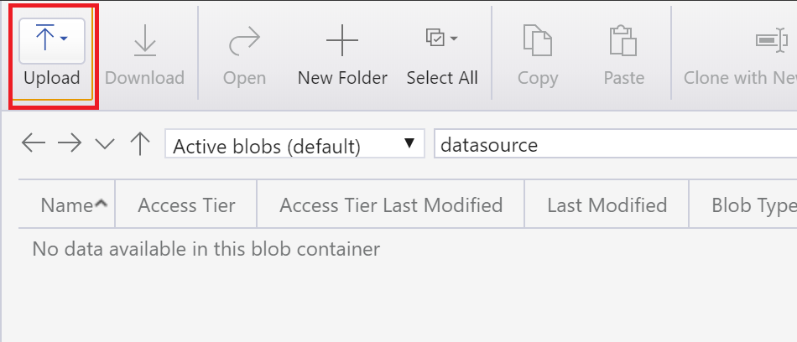

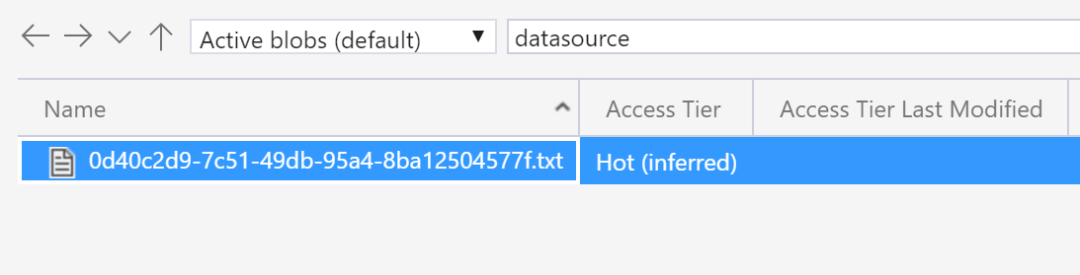

Clicking debug on the pipeline

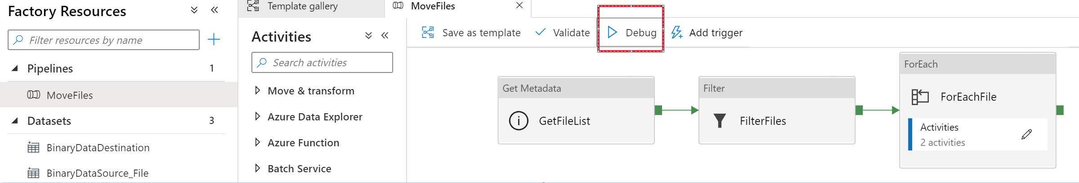

Clicking on the refresh we can see that it has completed.

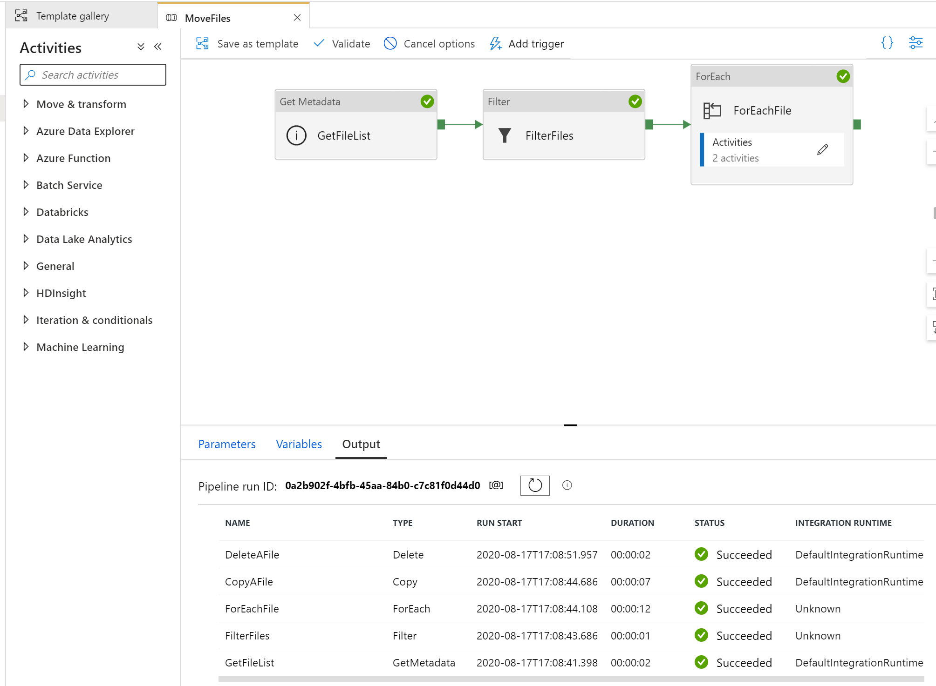

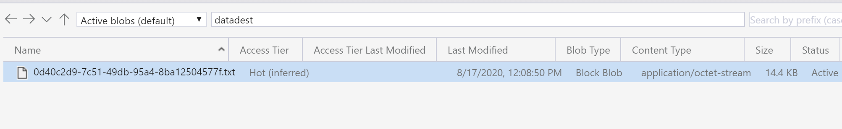

Create a trigger

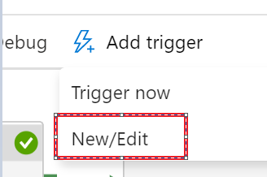

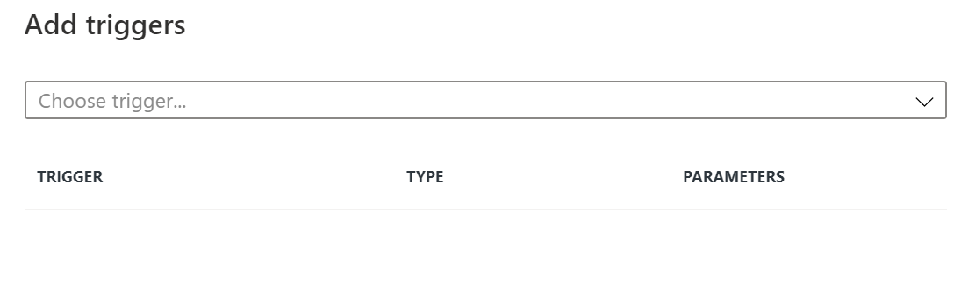

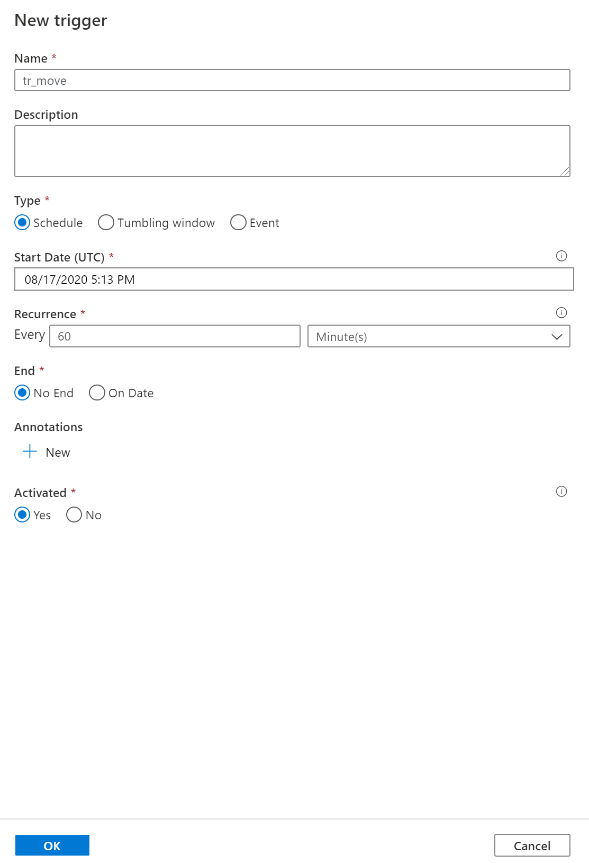

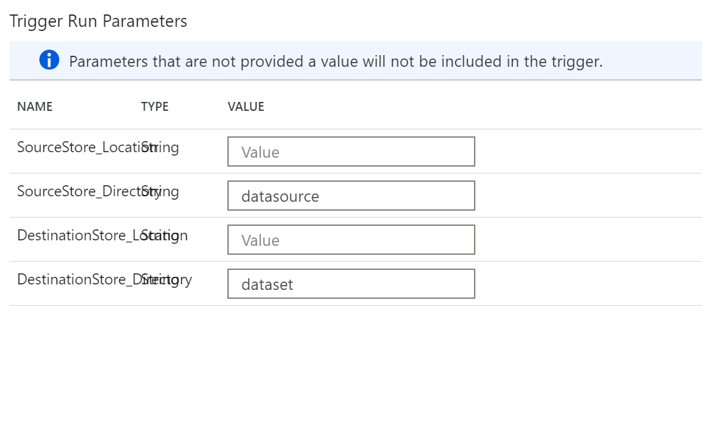

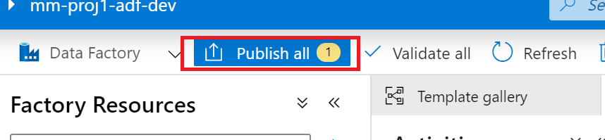

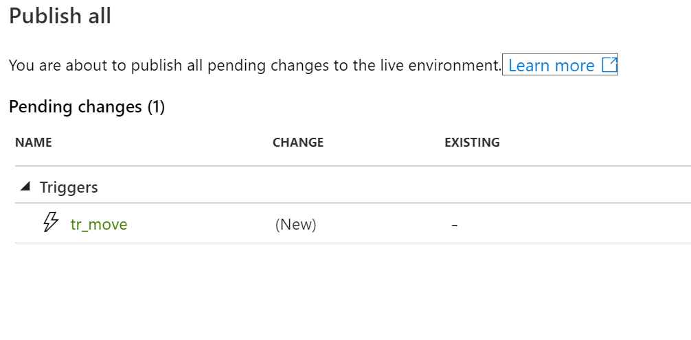

# Azure DevOps

### Dev Ops Organizations

Great resource to check out: [Plan Your Organizational Structure](https://docs.microsoft.com/en-us/azure/devops/user-guide/plan-your-azure-devops-org-structure?toc=%2Fazure%2Fdevops%2Forganizations%2Ftoc.json&bc=%2Fazure%2Fdevops%2Forganizations%2Fbreadcrumb%2Ftoc.json&view=azure-devops)

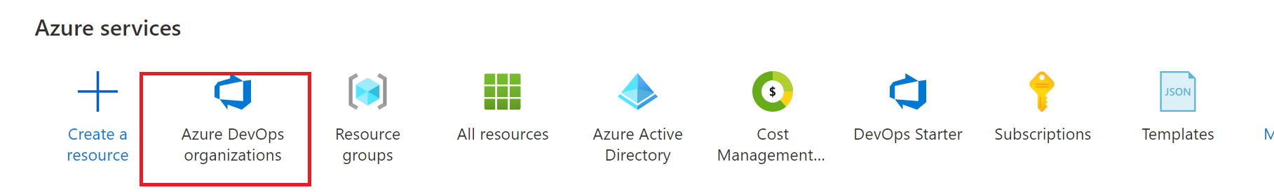

Ideally – you would add your project to an existing DevOps organization. So let’s check what you currently have.

Create a new organization if we need to. This would be a follow up to determine if there is a central team to work with.



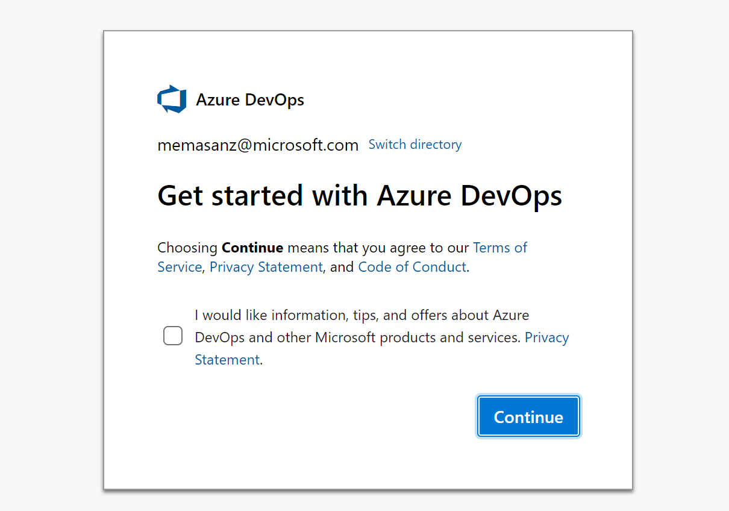

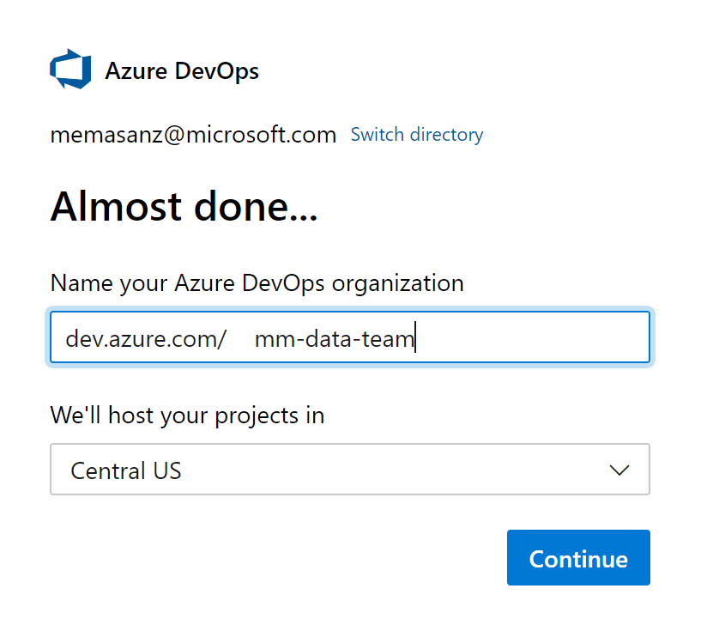

Then create a project

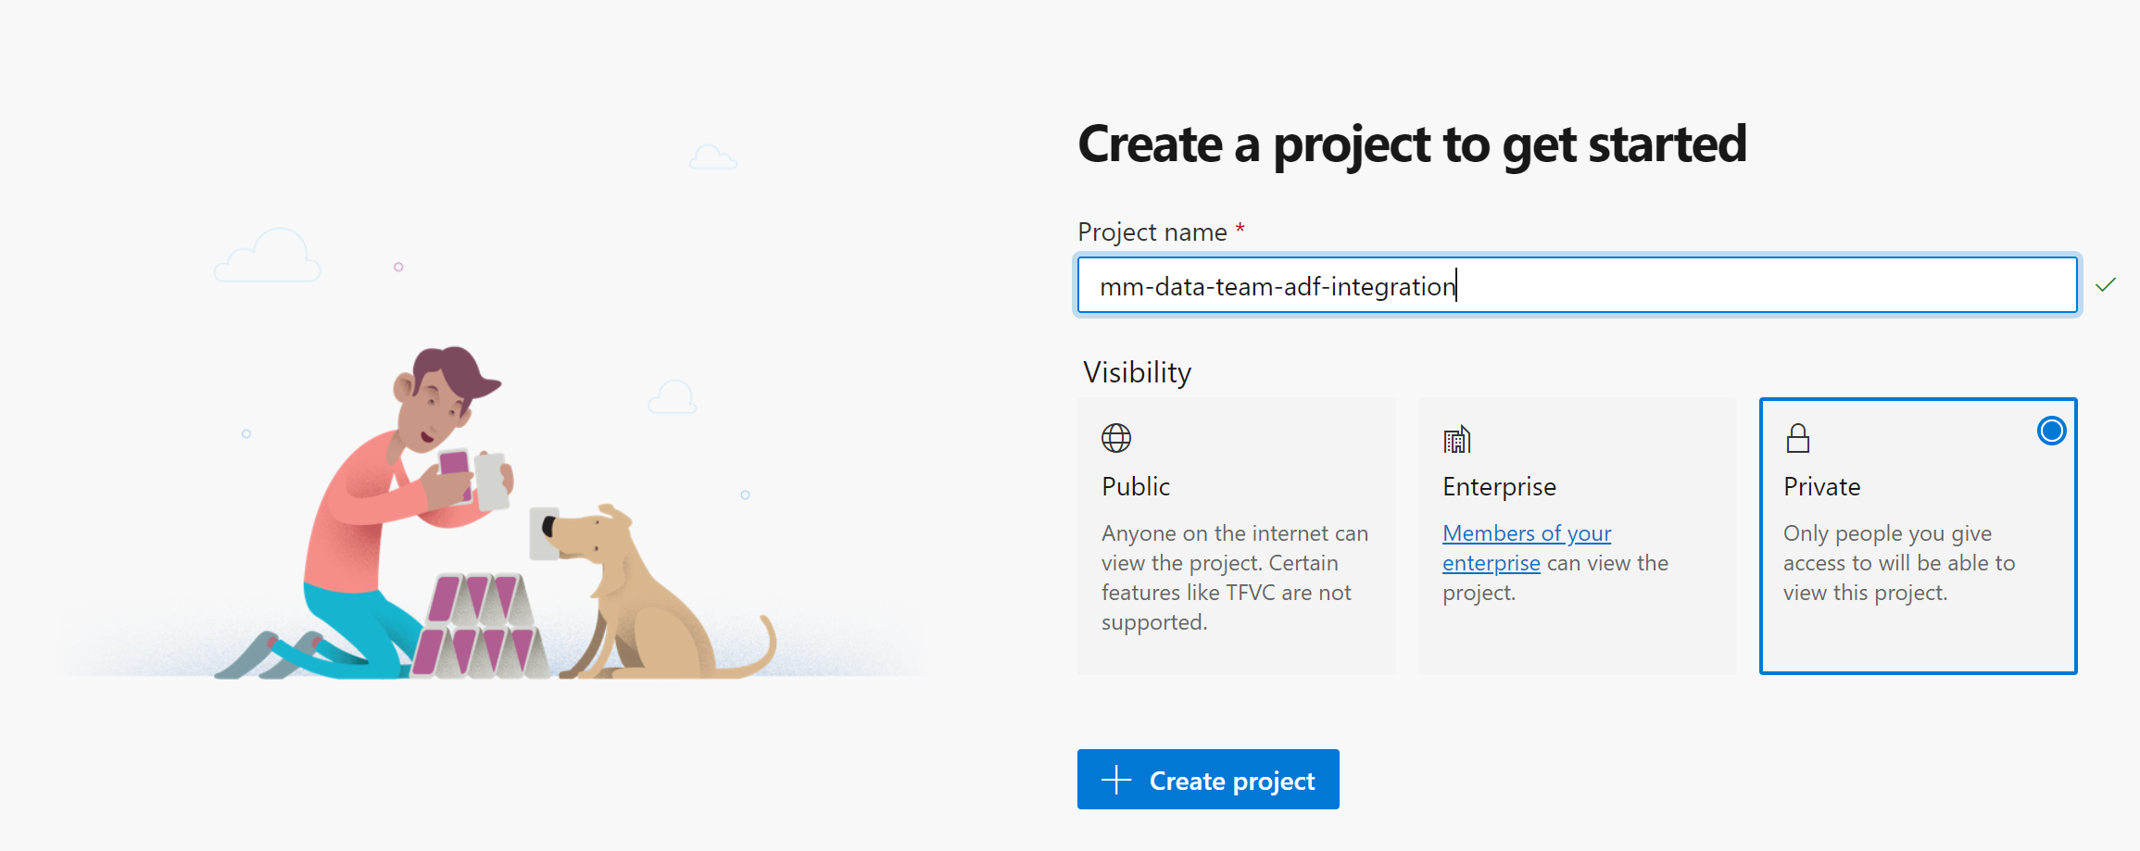

Click on the `Create project` button

# 

<http://dev.azure.com/>

Let’s head back to ADF and setup the link to our newly created project.



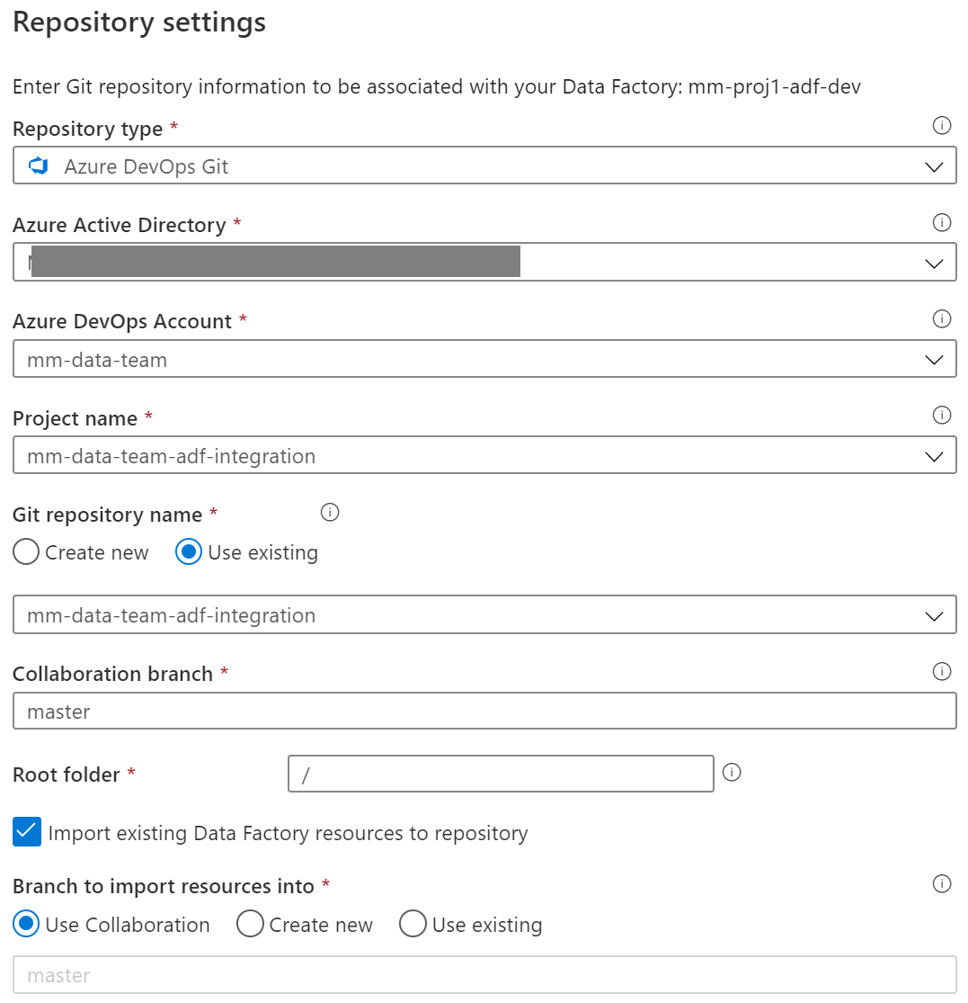

Let’s check back at the repo. *We currently only have a master branch*.

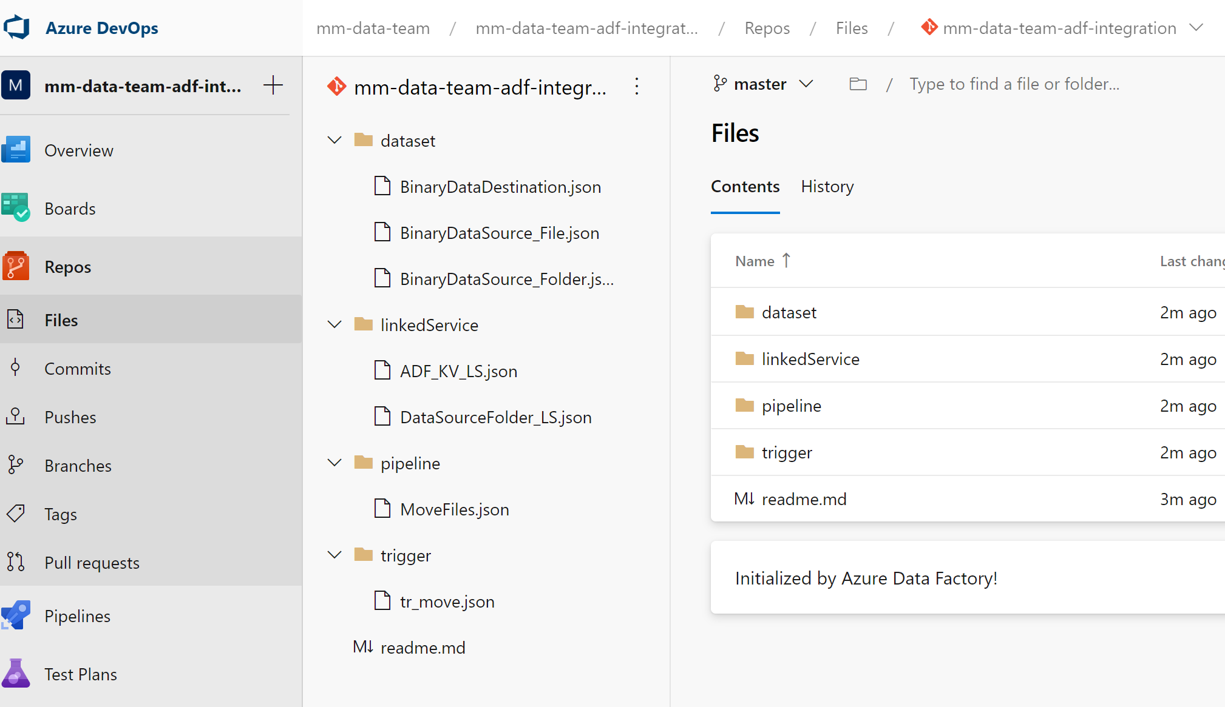

Going back into ADF we can select the ‘Publish’

On the collaboration branch ‘master’ when we publish we are generating the adf_publish branch

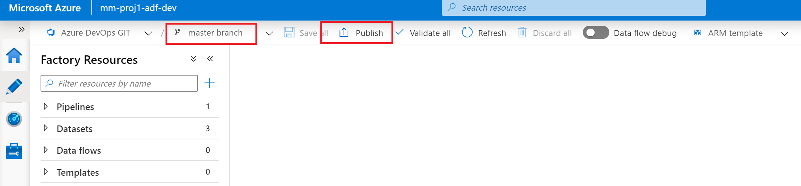

Going back into devOps project we can see the adf_publish branch, but it’s empty. The first time we need to make an arbituary change to generate the full adf_publish branch.

Below is changing the description on the master branch and then publishing

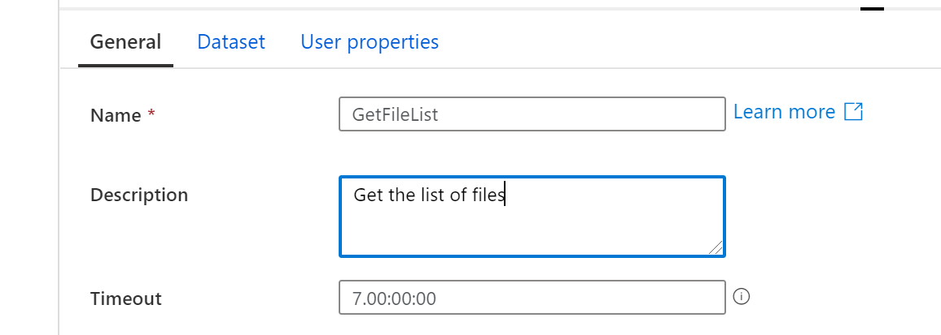

After that – checking the adf_publish branch will have the code.

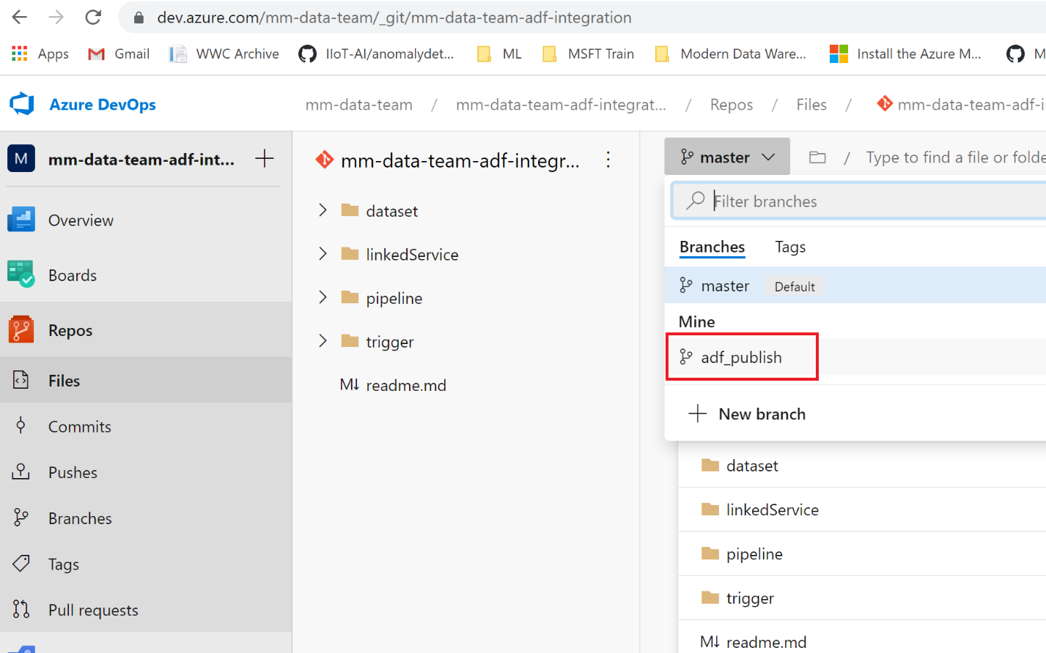

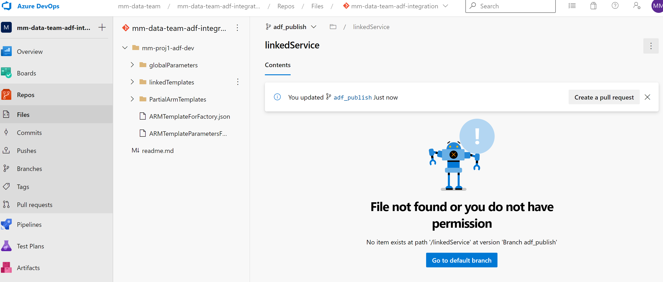

Create a Release Pipeline

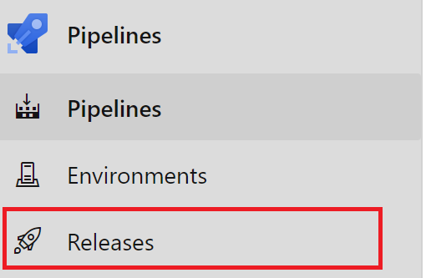

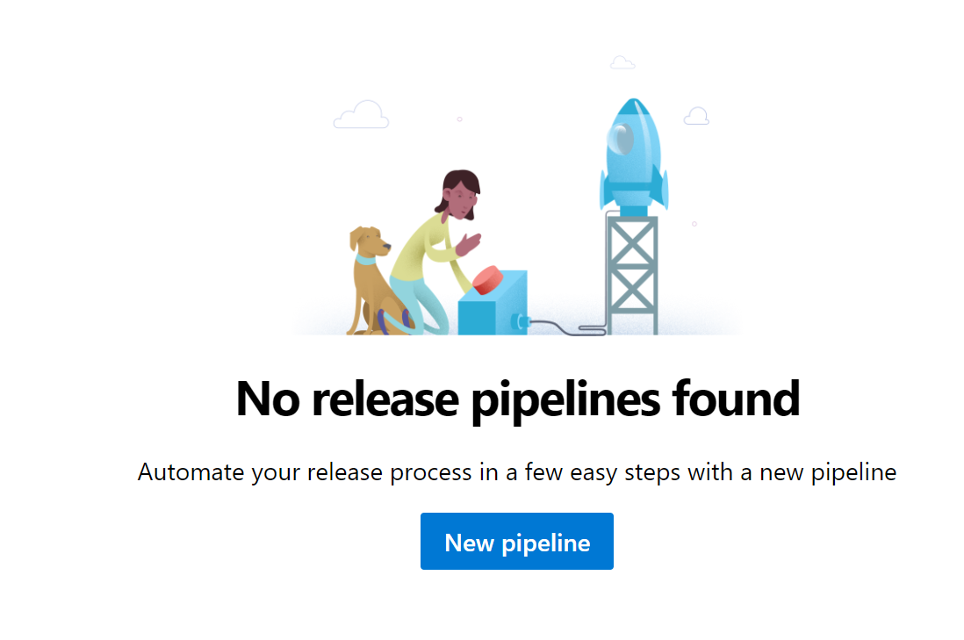

Select an Empty Job

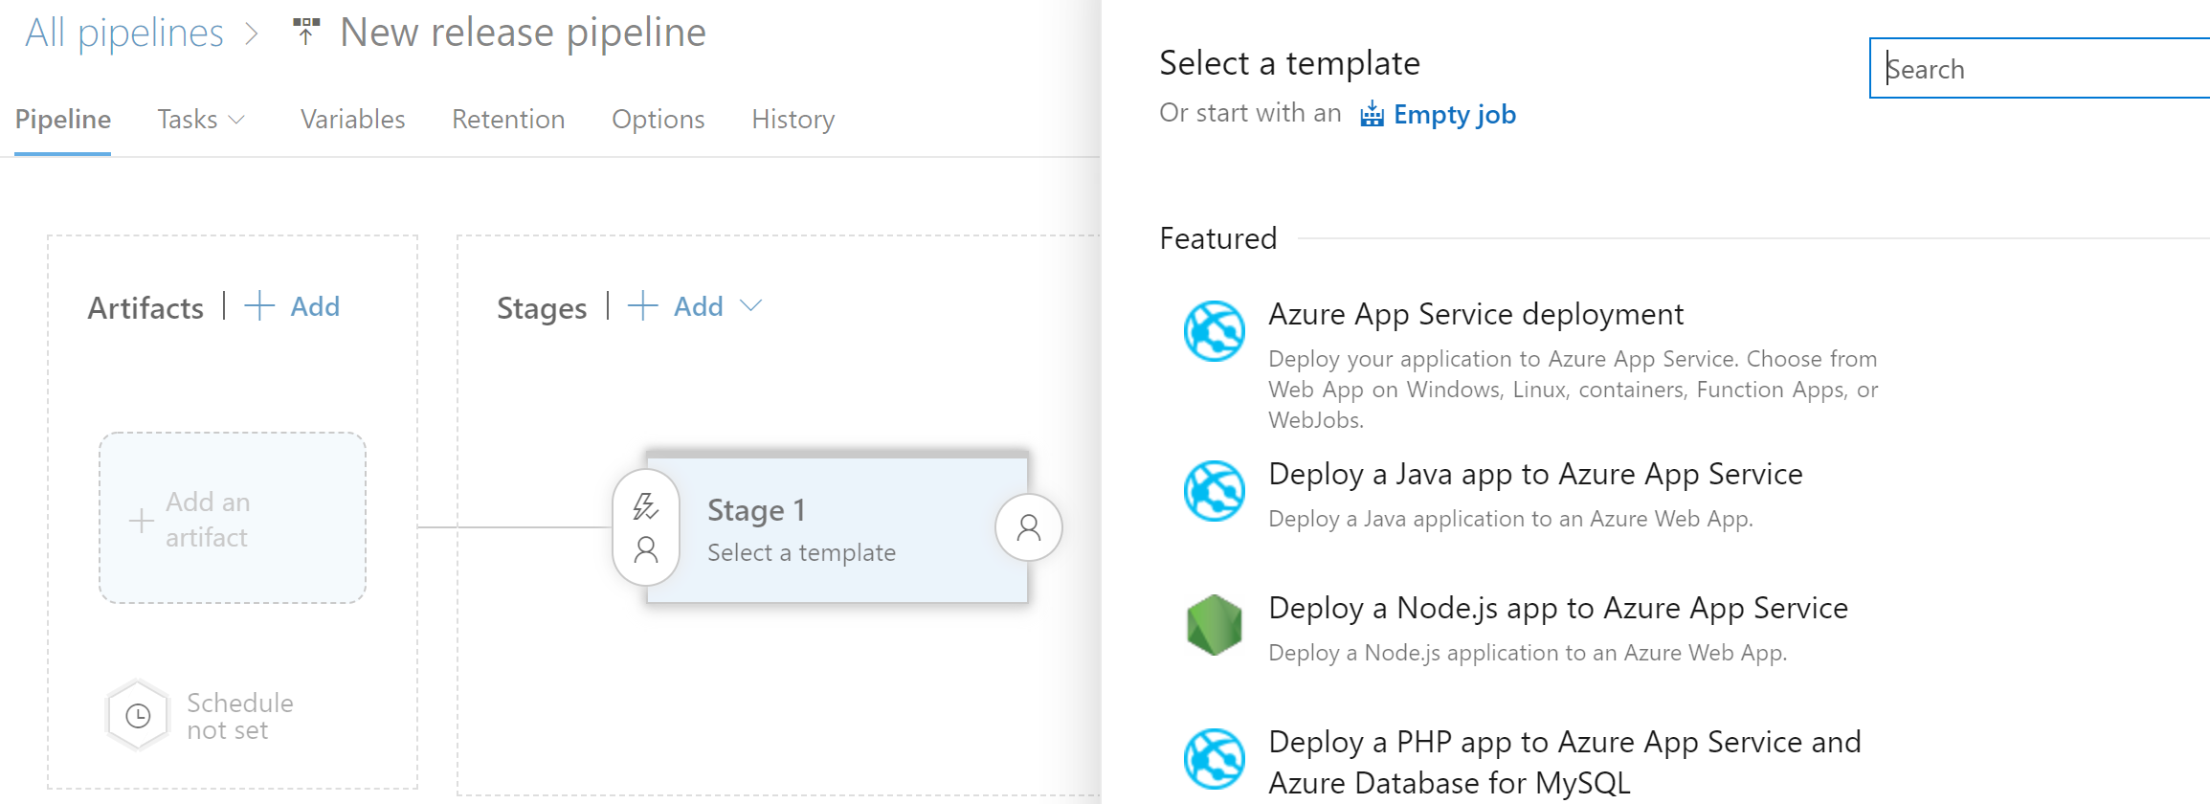

Rename the Stage to ‘QA’, close it with the X and rename the ‘New release pipeline’ to ‘ADF-Release-Pipeline’

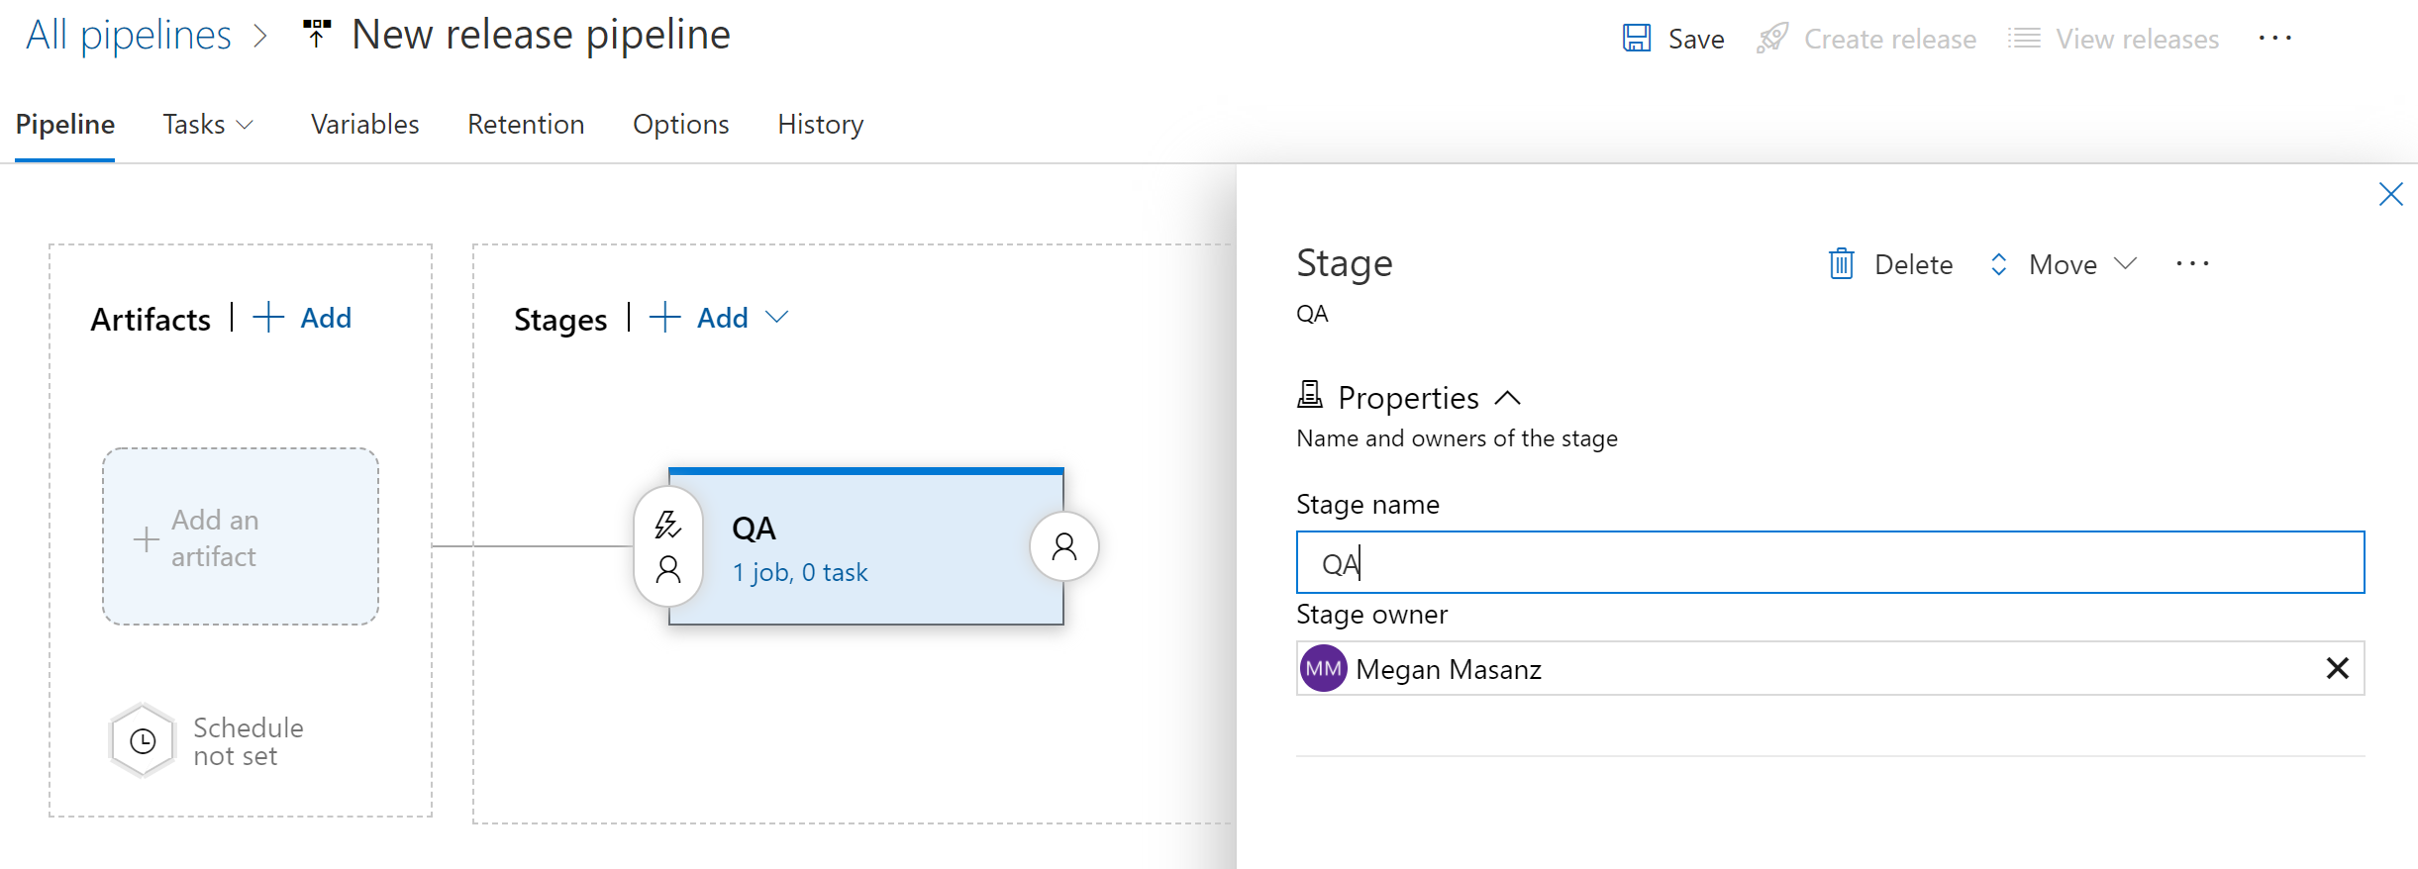

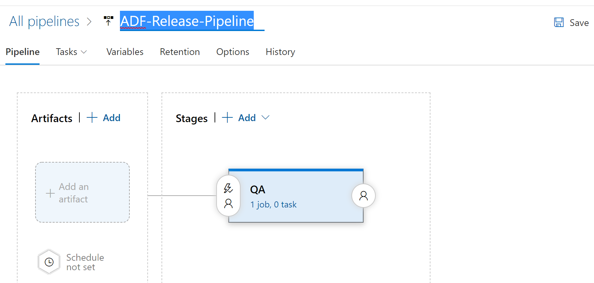

Don’t forget to the the ‘Save’ button.

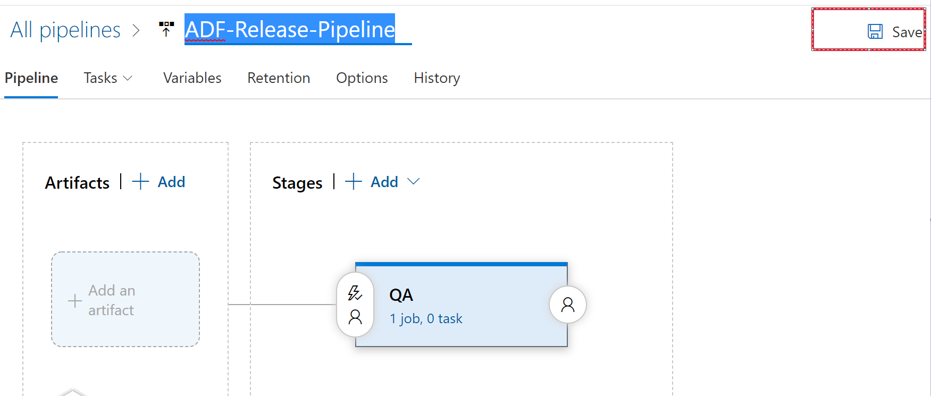

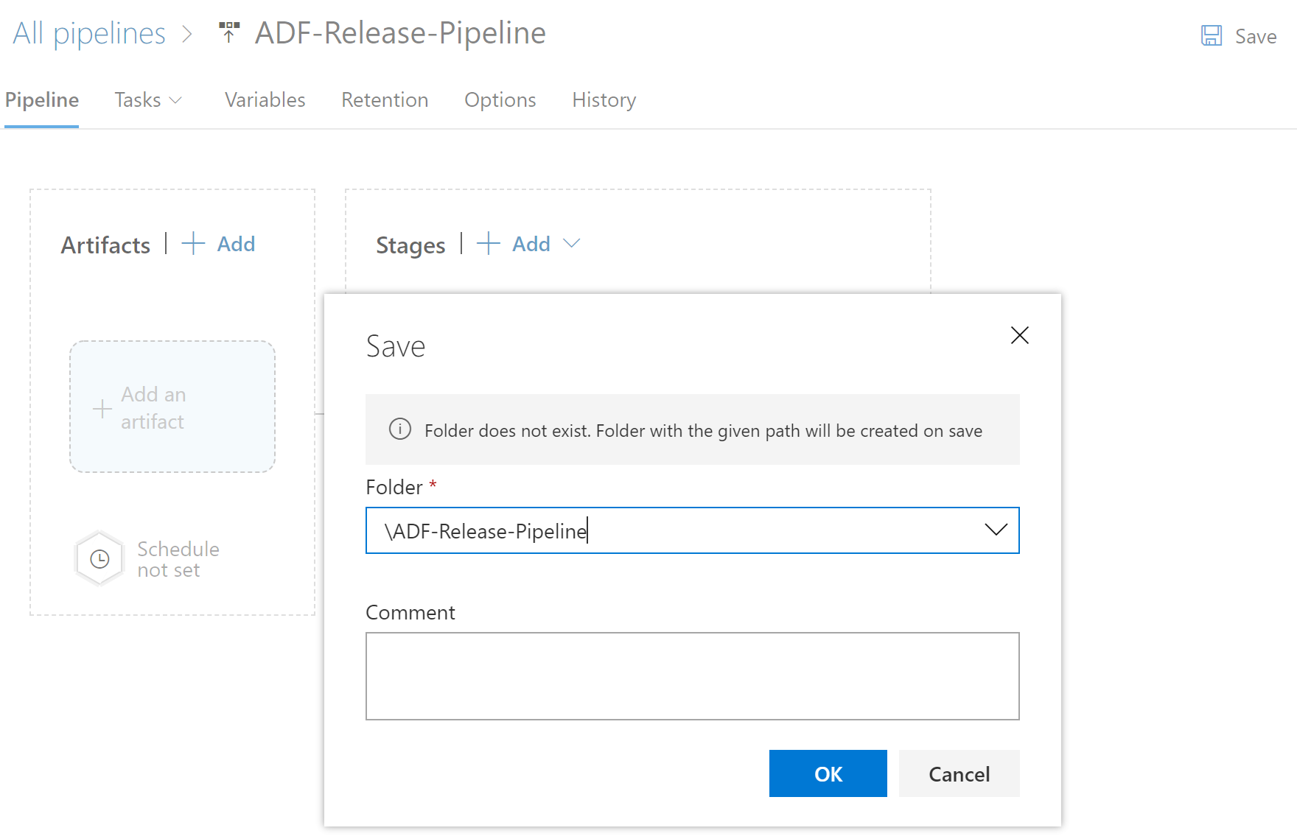

We will go and create some variable groups.

### Create Variable Groups

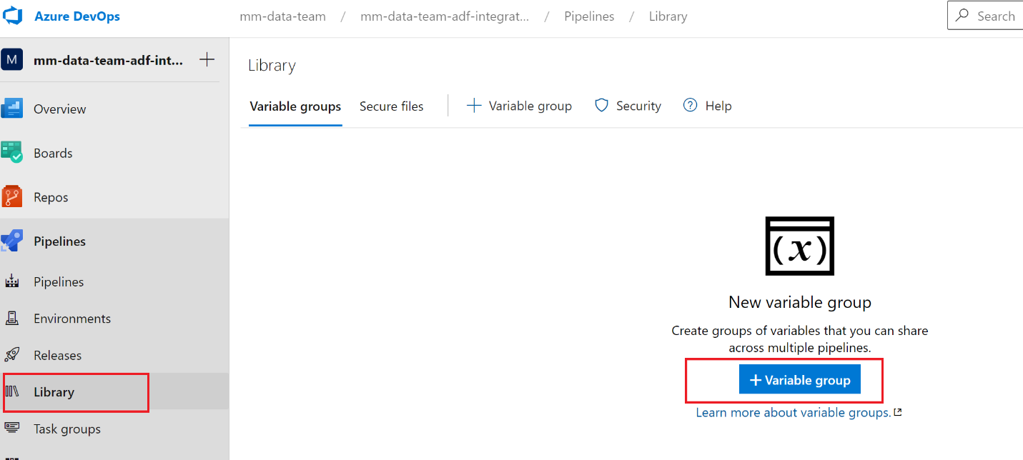

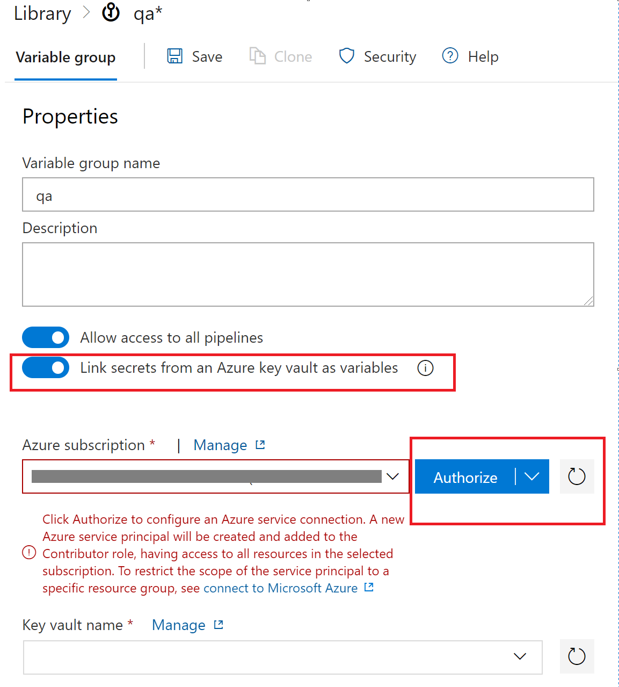

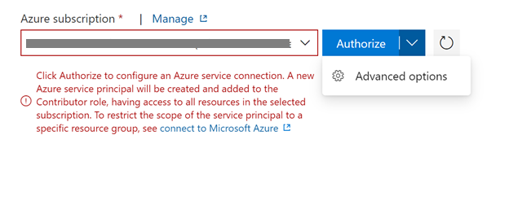

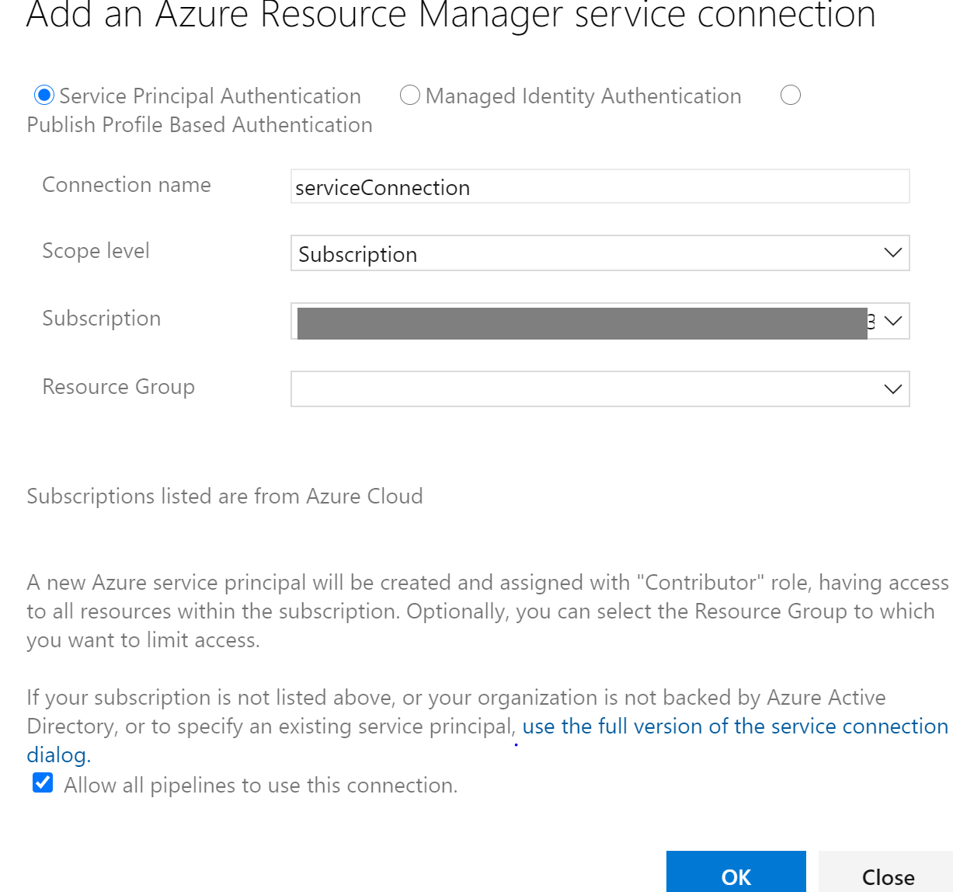

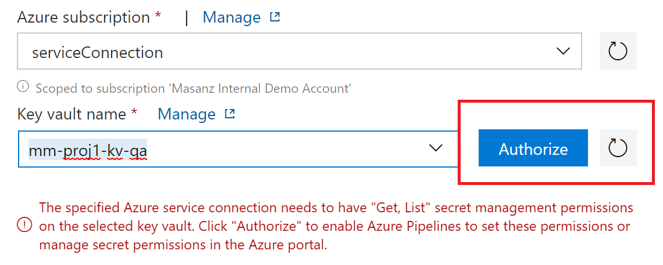

Next we will add the variables from key vault.

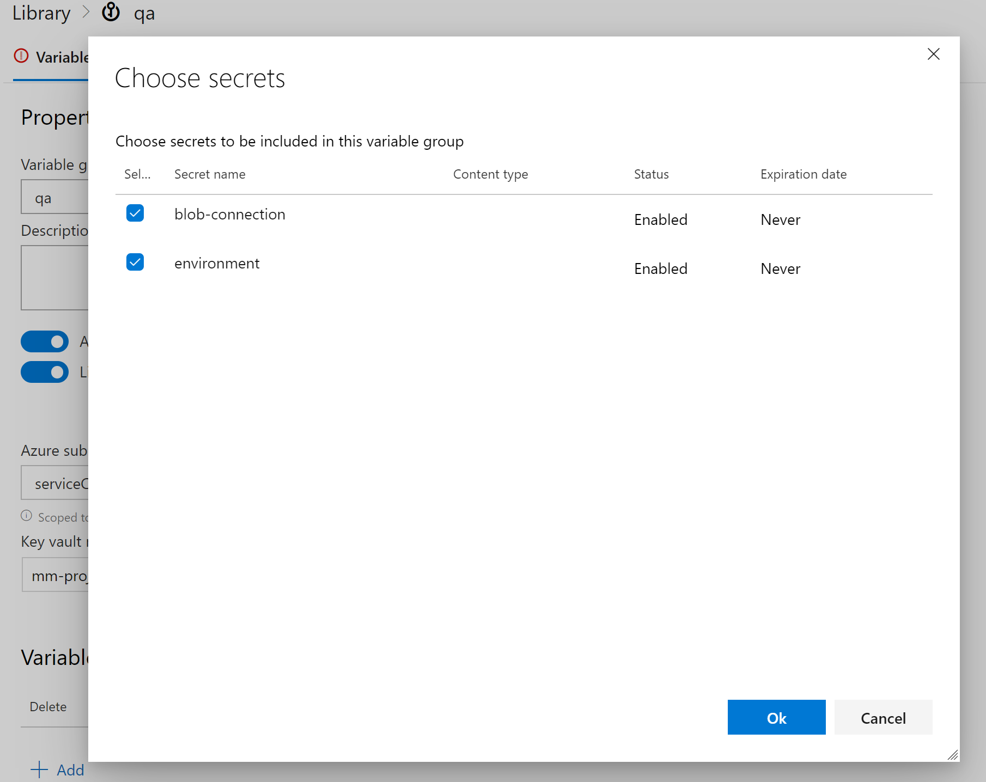

Then save the variable group.

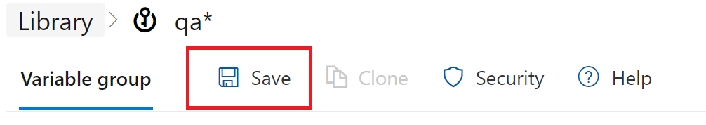

Create Prod and Authorize

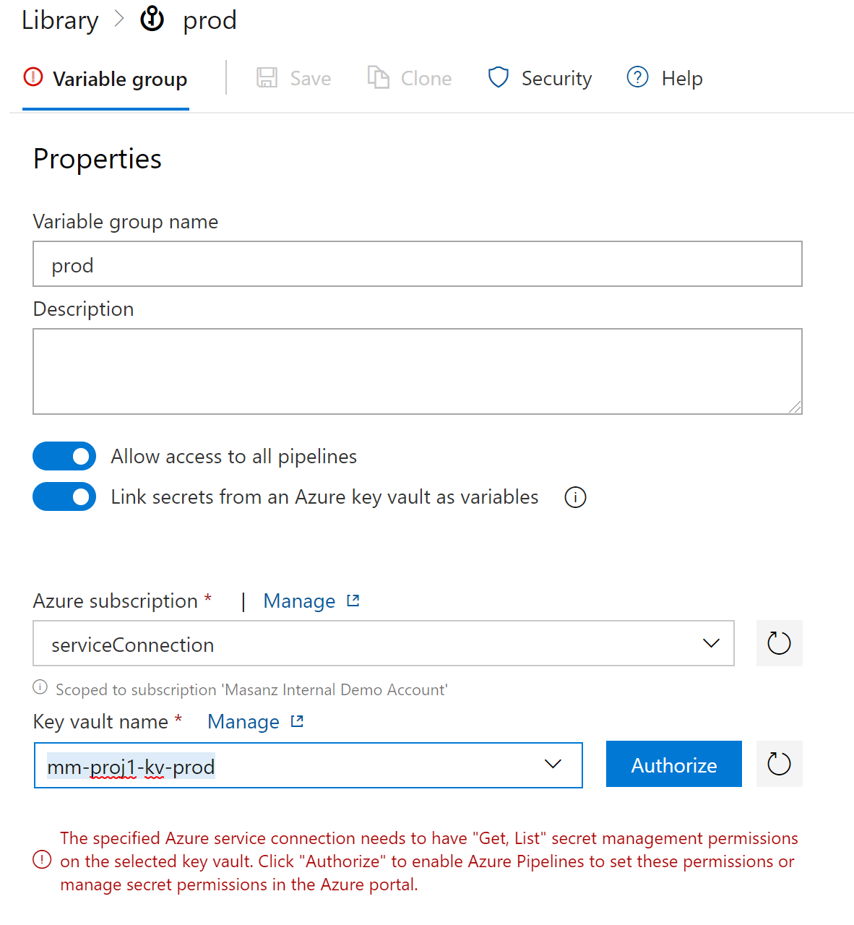

Then Add the prod variables

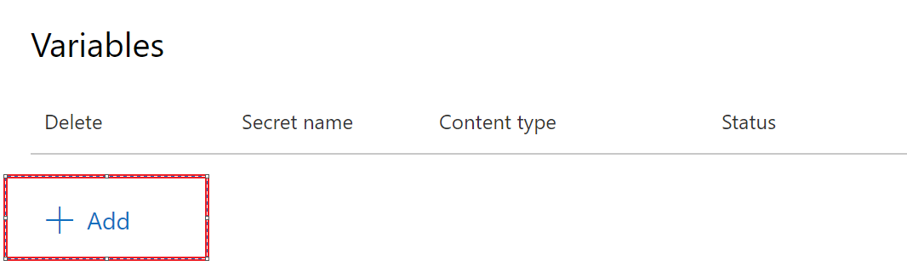

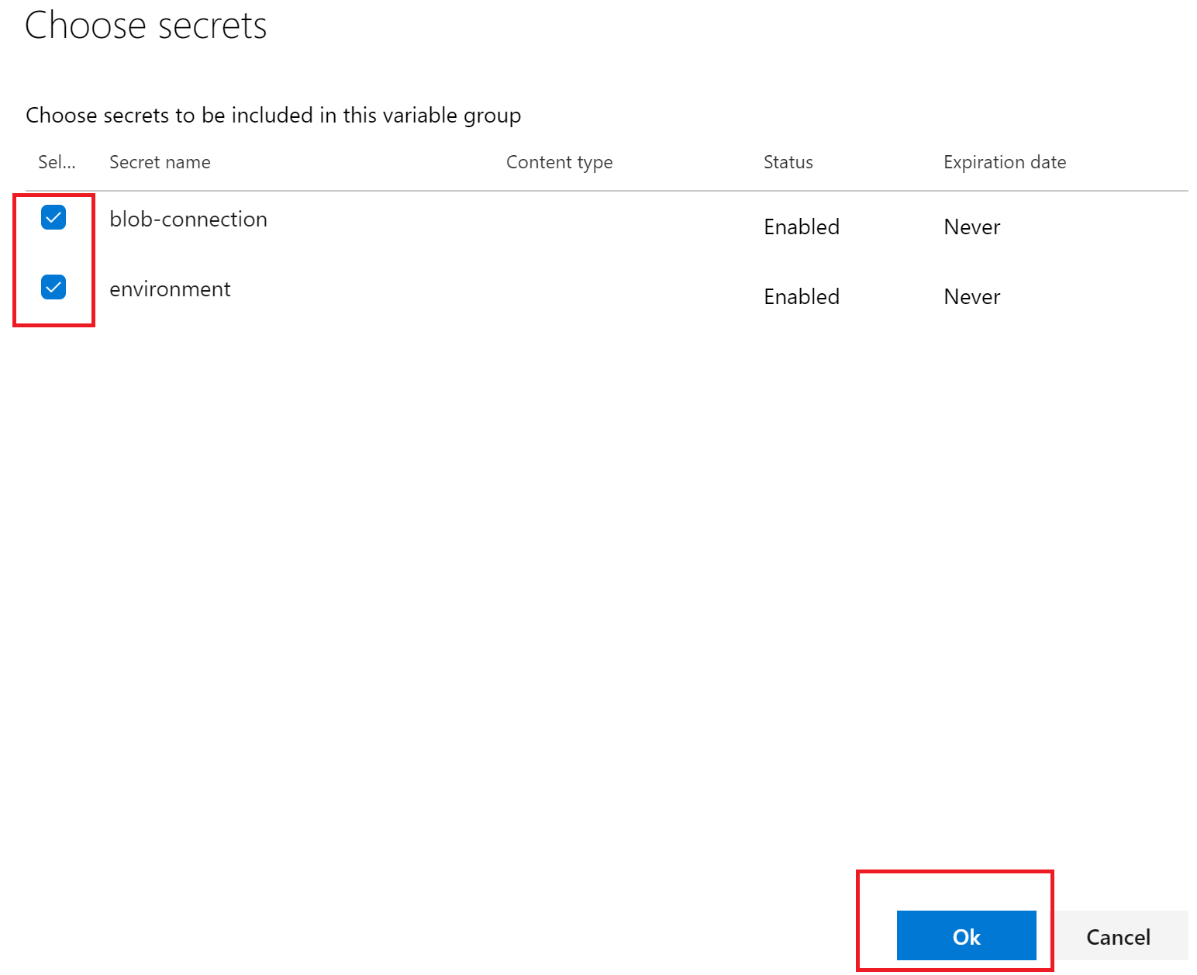

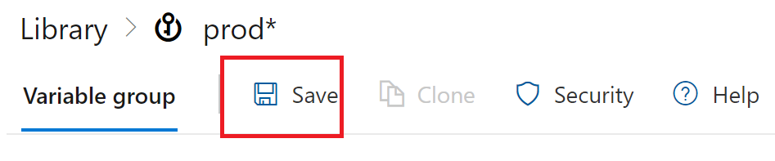

Now that we have the variable groups to use in the release pipeline we will go ahead and set them up.

Let’s go back into the releases

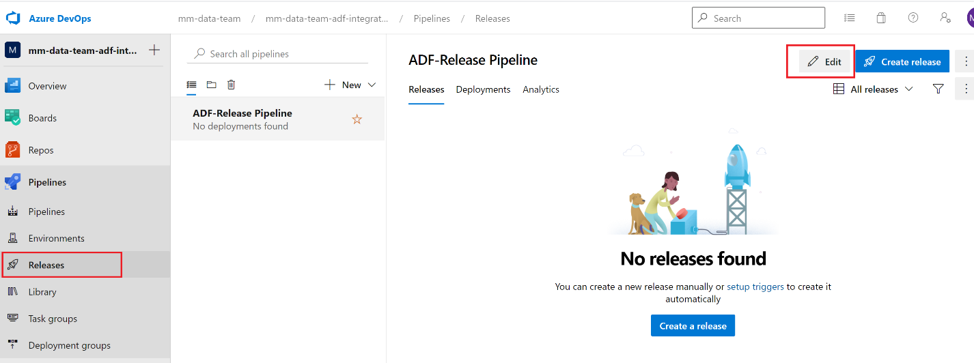

# Setting up deployment variables

Looking at the adf_publish branch you can see several variables.

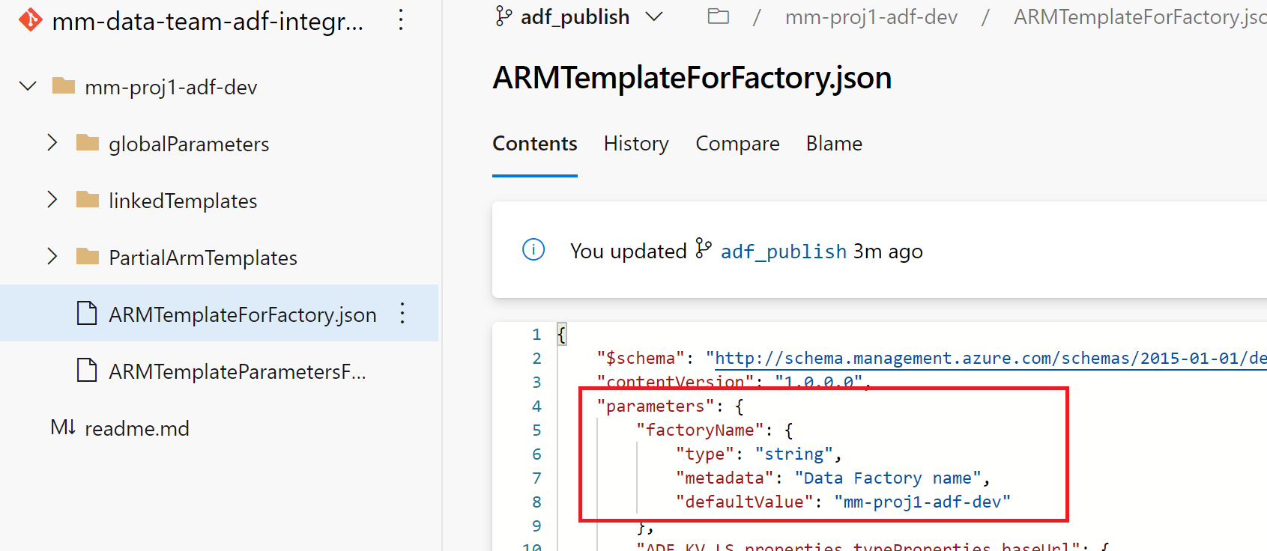

factoryName – is a pipeline variable.

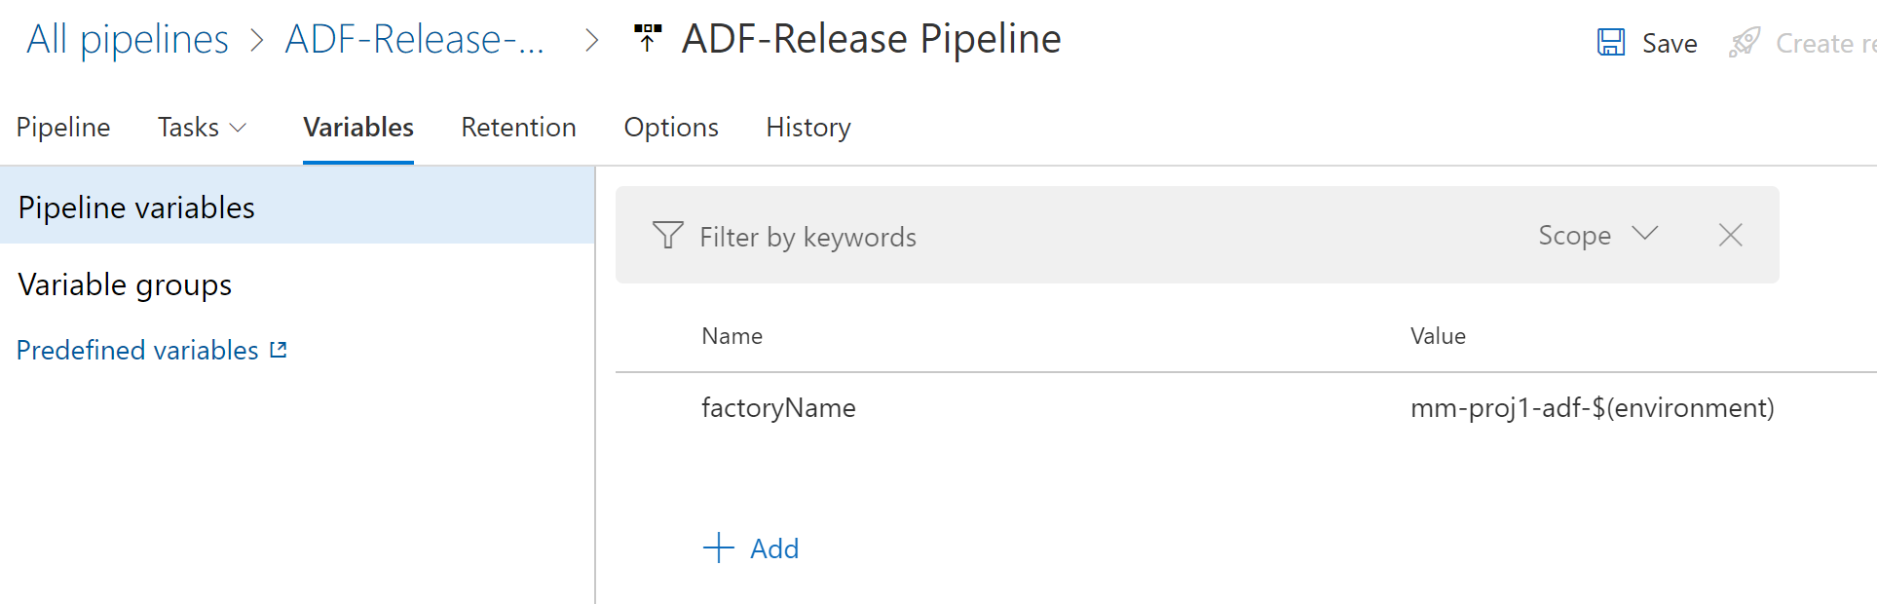

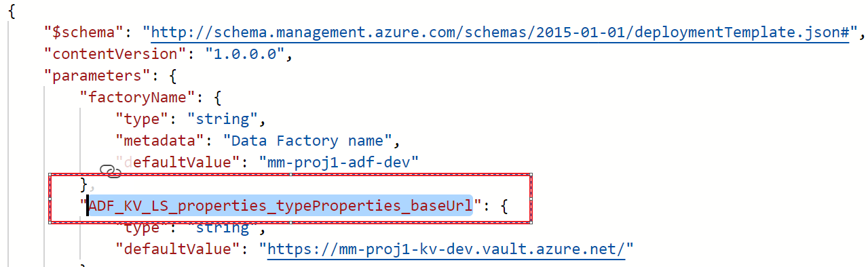

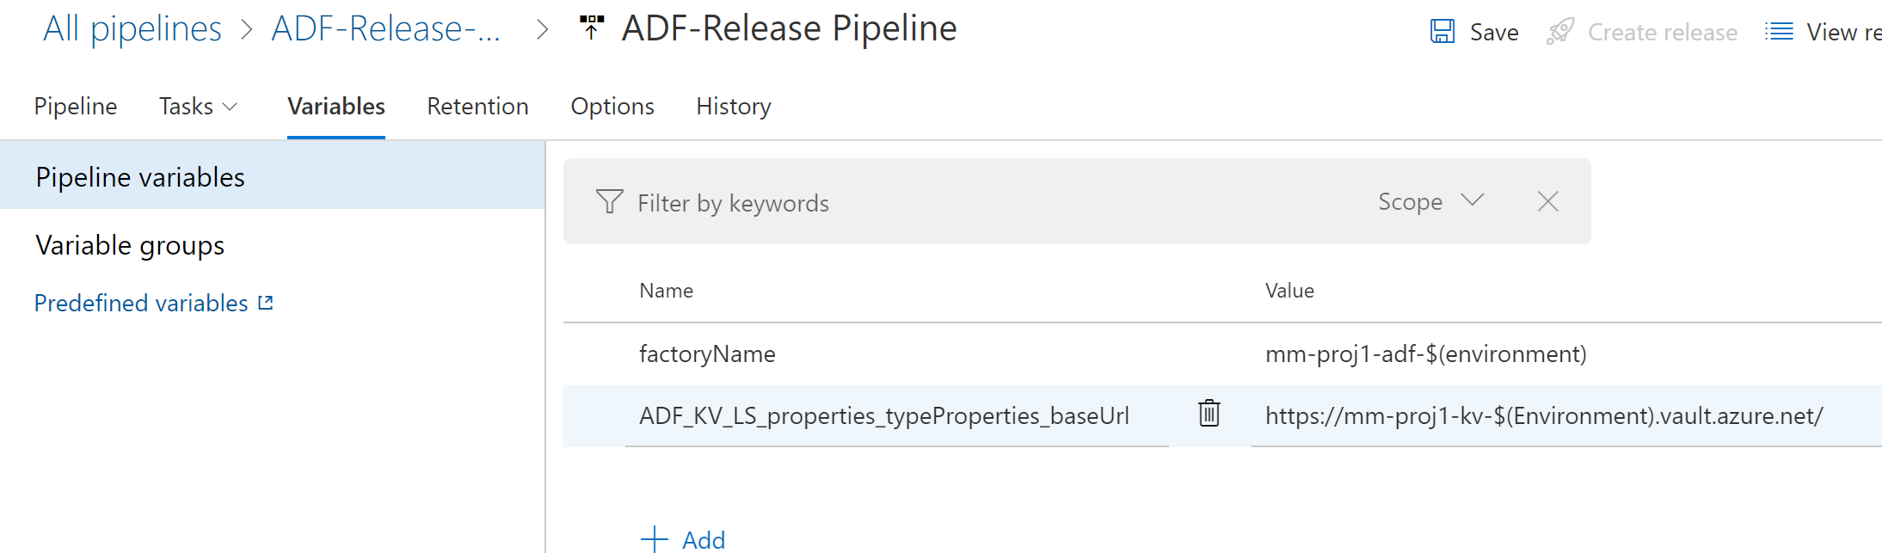



# Setting up the artifact

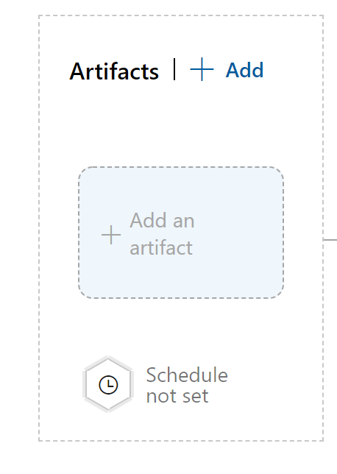

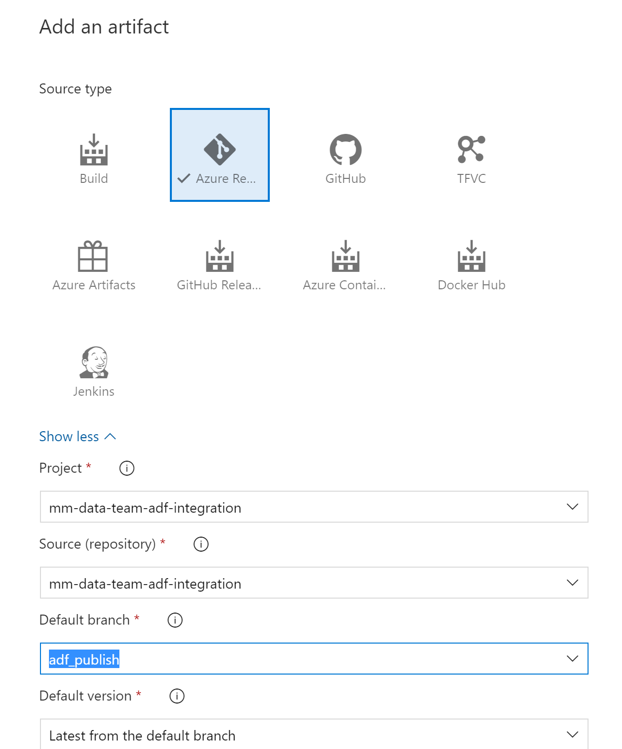

Click on the ‘Add’ button

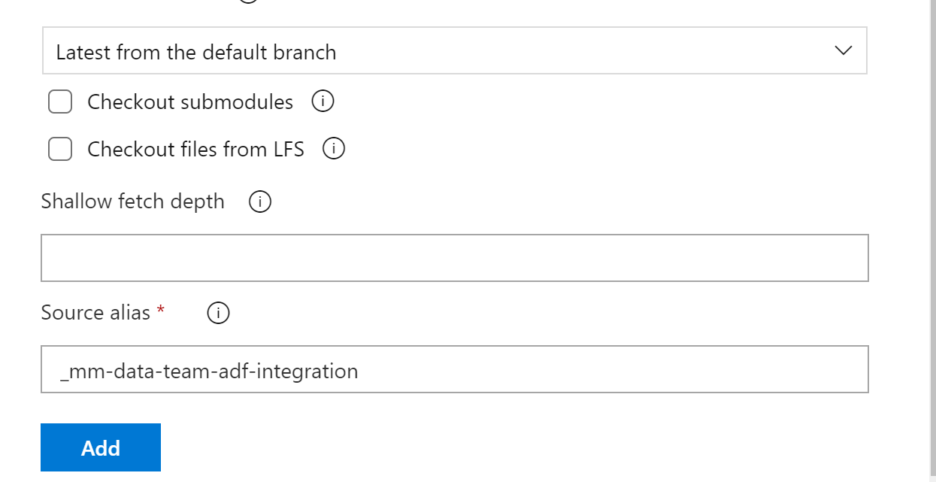

# Linking Variable Groups

Link qa to the QA stage.

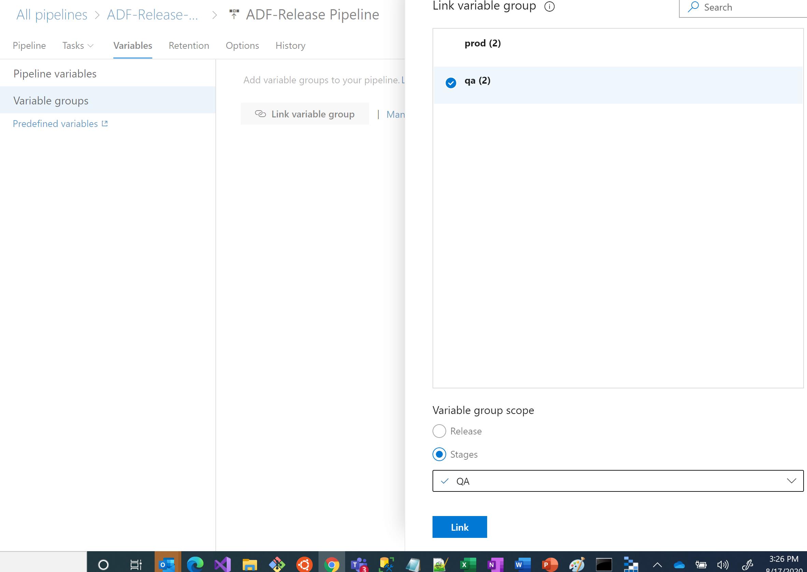

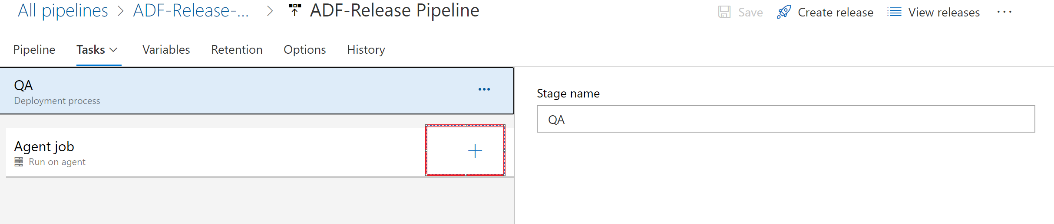

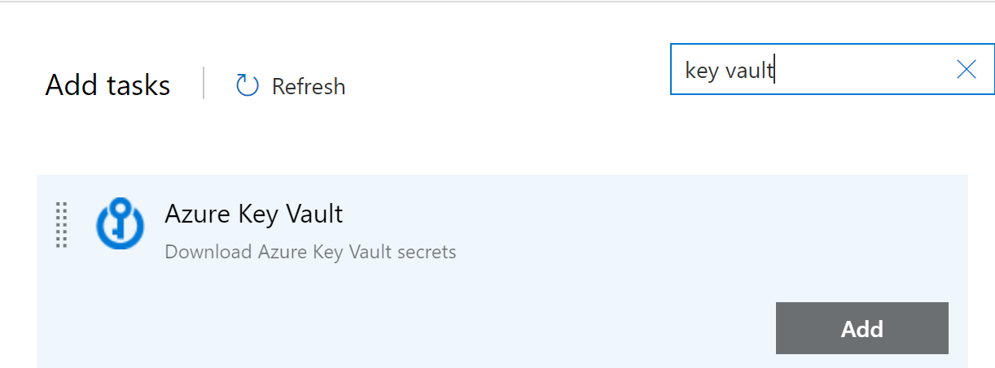

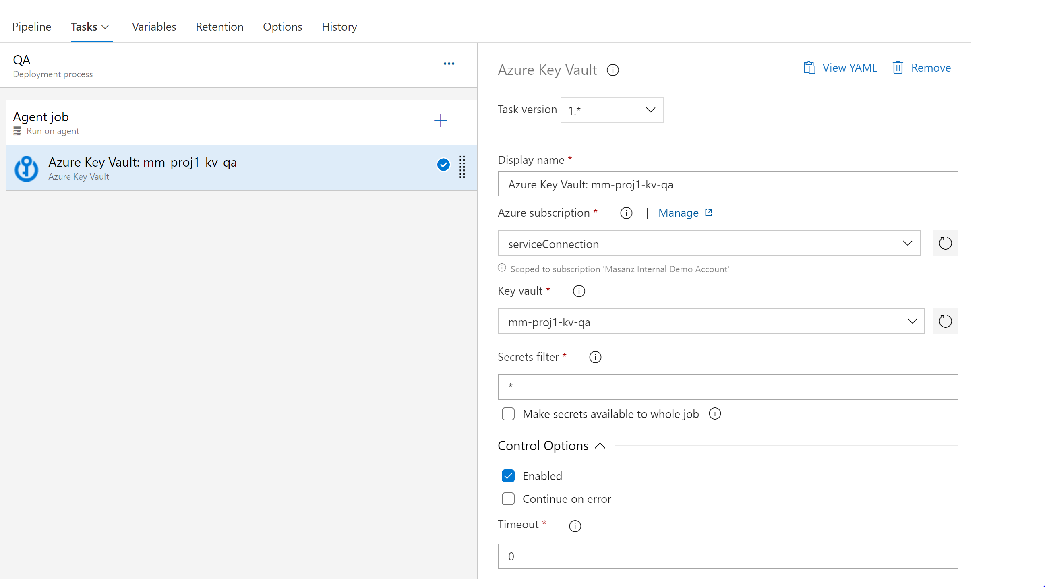

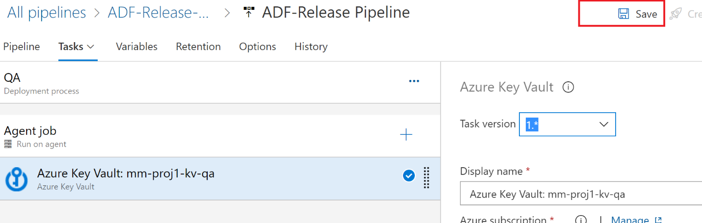

Add another task

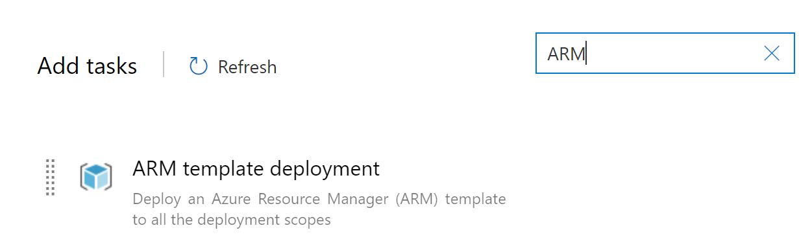

Click the `Add` Button

